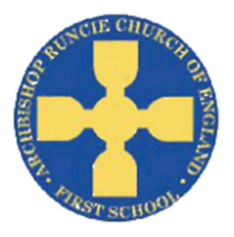

**‘Space’ Spring Term 2019 Year 1**

**History**

We will explore the history of space, and find out why we remember Neil Armstrong. We will use our historical skills to compare Neil Armstrong’s trip to space with Tim Peake’s.

**Science**

In Science we will be learning about the parts of the human body. We will explore which parts of the body are used for our 5 senses. We will then use this knowledge to carry out experiments using our senses.

**Physical Education**

In PE this term, we will be improving and building upon our fundamental movement skills. This will involve moving in different ways and using these movements to support skills such as throwing and catching. We will continue to complete the Daily Mile.

**Mathematics**

We will continue to focus on addition and subtraction, as well as Place Value within 50. This will include:

Representing and using number bonds and related subtraction facts within 20.

Using symbols + - =

+ and - 1 digit and 2 digit numbers to 20, including 0.

Solve one step problems that involve + and -

Count, read and write numbers to 50 in numerals.

Identify1 more/less

Count in multiples of 2’s, 5’s and 10’s

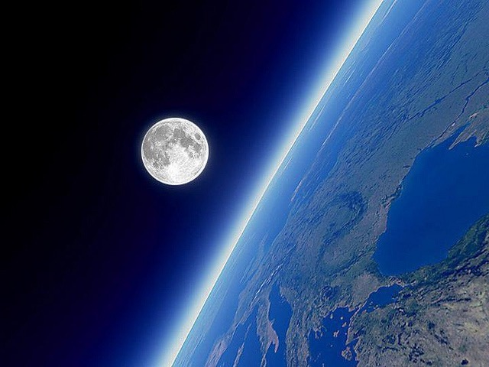

**Computing**

We will become artists, making our own illustration for Space pictures. We will learn how to use creative programs, save, open and retrieve our work in order to make improvements.

**Religious Education**

We will learn about the Gospel and begin to think about the good new Jesus brought and shared.

**English**

In English, we will be reading ‘The Darkest Dark’. The children will begin to compare different settings from the story. We will then explore the story, building on our sentence writing skills and producing our own story setting based on ‘The Darkest Dark’.

.

**Music**

We will study a song produced in six different styles; Blues, Baroque, Latin, Bhangra, Folk and Funk. The children will share their opinions of the songs/styles as well as learning to preform them.

**Design Technology**

To become a space explorer we need to build a space buggy. We will investigate the important features of a space buggy, design our own and finally build a prototype, using axles and wheels.