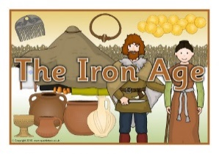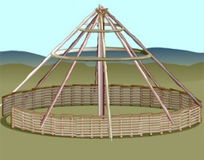

Year 4

**The Iron Age**

Spring Term 2

**RE:** In RE we will focus on our new ‘Understanding Christianity’ work looking at ‘salvation’. We will make simple links between the Gospel texts and how Christians mark the Easter events in their church communities. We will also escribe how Christians show their beliefs about Palm Sunday, Good Friday and Easter Sunday in worship.

**Maths**: We will cover the following areas:

**Decimals:**

* Recognise and write decimal equivalents of any number of tenths or hundredths.
* Find the effect of dividing a one or two digit number by 10 or 100, identifying the value of the digits in the answer as ones, tenths and hundredths.
* Solve simple measure and money problems involving fractions and decimals to two decimal places.

**Money:**

* Estimate, compare and calculate different measures, including money in pounds and pence.
* Solve simple measure and money problems involving fractions and decimals to two decimal places.

**PE:** In PE this term we will continue to develop flexibility, strength, technique, control and balance through athletics.

**Computing:**

In Year 4 we will continue to use Scratch to develop our coding skills. We will set the appearance of objects and create sequences of changes.

We will also create and edit sounds to control when they are heard, their volume, duration and rests.

**Science**: In Science we will continue to investigate sound. We will identify how sounds are made, associating some of them with something vibrating and recognise that vibrations from sounds travel through a medium to the ear. We will find patterns between the pitch of a sound and features of the object that produced it.

**DT:** We will cut materials accurately and safely by selecting appropriate tools and measure and mark out to the nearest millimeter in order to create a 3D model of an Iron Age roundhouse.

**History:** We will investigate and interpret the past by exploring the Iron Age. We will look at tribal kingdoms, farming, arts and culture. We will use appropriate historical vocabulary to communicate, including:

    • dates

    • time period

    • era

    • change

    • chronology.

We will also use literacy, numeracy and computing skills to a good standard in order to communicate information about the past.

**Personal, Social, Health Education and Citizenship:**

We will discuss financial capability, relating it to real-life situations.

**English:** Wewill be able to distinguish between explanatory texts and reports and recounts; Year 4 will be able to identify the structure and language features of an explanation text and then use this to evaluate and improve their own explanation text based on our topic ‘The Iron Age’. We will then move on to non-chronological reports by gathering information from a wide range of sources to compare two or more subjects. We will be able to write our own non-chronological report from information gathered.

**Geography:** We will describe and understand key aspects of: physical geography, including: climate zones, biomes and vegetation belts, rivers, mountains, volcanoes and earthquakes.

**Music:** We will perform by maintaining a simple part within a group, performing with control and awareness of others. We will continue to learn the ukulele and enjoy playing together in unison.