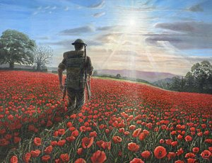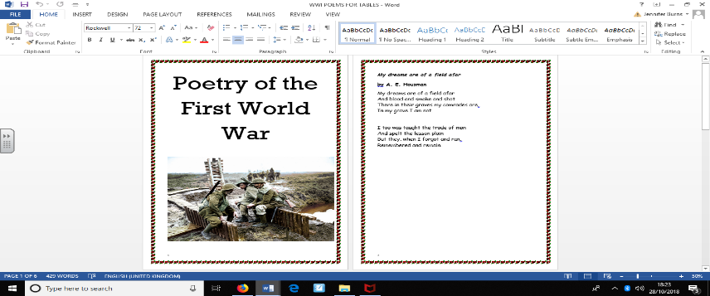

**History**

The children will use a range of sources to investigate and interpret the past. We will use more than one source of evidence for historical enquiry in order to gain a more accurate understanding of WWI.

**‘World War One’ 2018 Year 4**

**Science**

We will continue to investigate living things and their habitats. We will recognise that environments can change and that this can sometimes pose dangers to living things. We will then construct and interpret a variety of food chains, identifying producers, predators and prey.

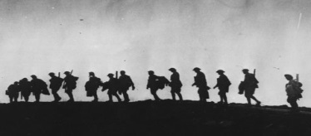

**Physical Education**

In PE this term we will be continuing to work with Andrew Vince from North East Skills Training. The children will be using running, jumping, throwing and catching in isolation and in combination to complete a range of different PE activities e.g. benchball, handball, FUNDS.

**Computing**

We will continue to use Scratch to design and make an educational game. We will then become toy designers, using Scratch to create a toy simulation by setting the appearance of objects and creating sequences of changes.

**Mathematics**

We will be focusing on measurement (distance- km/m and area/perimeter) and multiplication and division including:

• Convert between different units of measure (kilometre to metre)

• estimate, compare and calculate different measures (distance)

• measure and calculate the perimeter of a rectilinear figure (including squares) in centimetres and metres

• find the area of rectilinear shapes by counting squares

• estimate, compare and calculate different measures (distance)

* recall multiplication and division facts for multiplication tables up to 12 × 12
* use place value, known and derived facts to multiply and divide mentally, including: multiplying by 0 and 1; dividing by 1; multiplying together three numbers
* recognise and use factor pairs and commutativity in mental calculations
* multiply two-digit and three-digit numbers by a one-digit number using formal written layout
* solve problems involving multiplying and adding, including using the distributive law to multiply two digit numbers by one digit, integer scaling problems and harder correspondence problems such as n objects are connected to m objects.

**Art**

We will collect information, sketches and resources linked to WWI. We will then use a number of brush techniques using thick and thin brushes to produce shapes, textures, patterns and lines, experimenting with creating mood with colour.

**English**

In English we will read and analyse a range of poetry from World War One. We will study two poems in particular, ‘Who’s for the game?’ and ‘Flanders Fields’. We will describe the impact and effect of the poem on the reader based on the language chosen by the poet. We will then use this information to write our own poetry based on World War One and remembrance. Further on in the term we will be focusing on traditional folk tales where the children will write their own traditional folk tale using the purpose, structure and language features of folk tales.

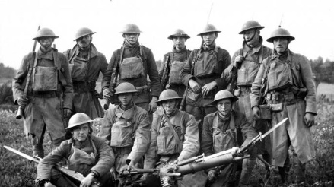

**Religious Education**

We will investigate the key question ‘What do Christians learn from the creation story?’ using the stimulus of ‘The Big Frieze. We will then explore the Christian festival of Christmas.

**Music**

The children will continue to learn new tunes on their recorders. The key performance skills we will develop in music are to sing from memory with accurate pitch and in tune whilst maintaining a simple part within a group.

**DT**

We will understand and apply the principles of a healthy and varied diet by preparing and cooking a variety of predominantly savoury dishes linked to rationing during WWI.

**Geography**

We will locate the world’s countries, using maps to focus on Europe and locations related to World War One. We will investigate the lasting effects of the War on the geography of the land and understand how some of these aspects have changed over time.