Bubble Blowers
This scientific practical is all about homemade bubble blowers.
Equipment
You will need:
- Washing up liquid
- Water
- Plastic straw
- Scissors
- Smooth surface like a marble bench
- Cup

Instructions
- First, you will need to get your scissors and cut the straw in half length ways so that you have two short straws.
- Second, cut the top of the straw into quarters and bend the four pieces down into a flower shape, like the picture below.
- Next, get your cup and put the washing up liquid and water into the cup. Ratio, liquid to water 1:3.
- Now just stir it with the straw and you are ready to go!
Buble Igloos
- You can blow bubble igloos by covering your bench in the soapy water.
- Blow a bubble with your straw then place it on the bench and continue to blow.
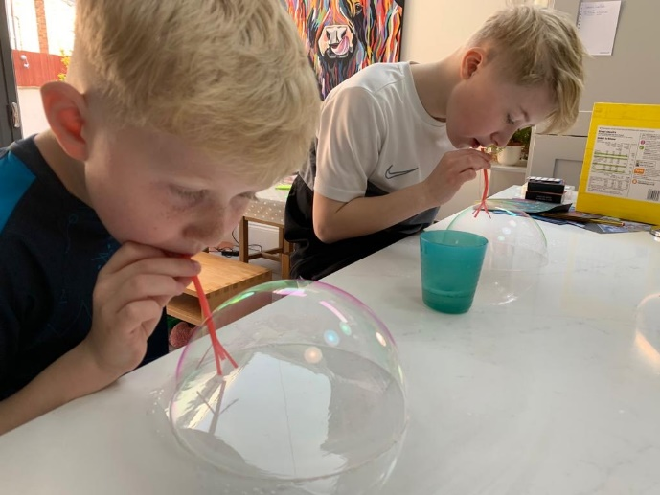

Bubble Forcefield
- Wet your hands with soapy water.
- Blow your bubble with the straw then put it onto your hand and make a bubble force field.
- While your bubble is on your hand you can put your straw inside of the bubble and blow to make it bigger.
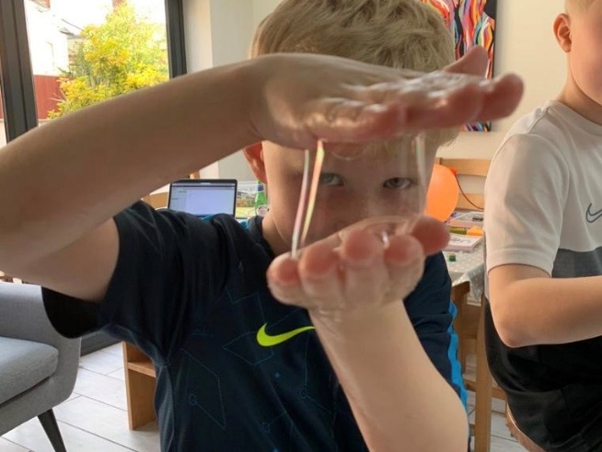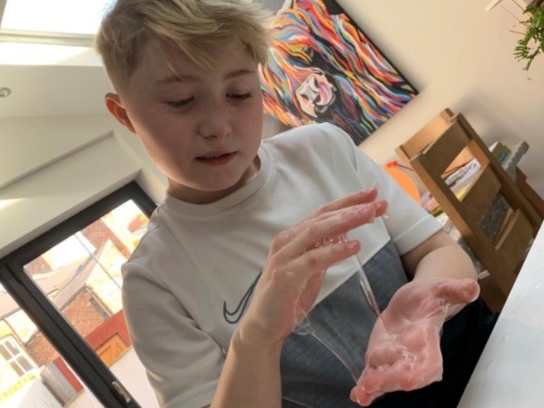

Challenges
Can you put a bubble inside a bubble?
Can you make a bubble caterpillar?
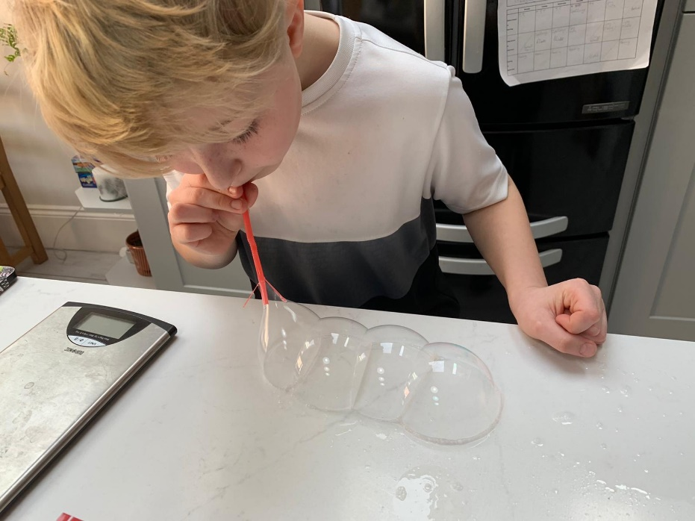
Why?
Do you need to blow slowly or fast? Why?
What would happen if you cut the end of the straw more than 4 times? Will it still work?

