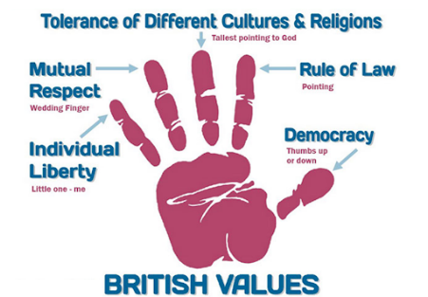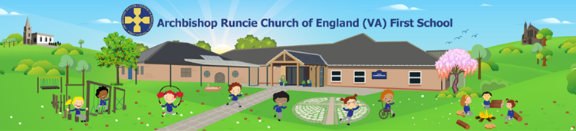

**Fundamental British Values at Archbishop Runcie First School**

|  |  |  |  |  |  |
| --- | --- | --- | --- | --- | --- |
| **Links** | **Individual Liberty** | **Mutual Respect** | **Rule of Law** | **Tolerance** | **Democracy** |
| **Curriculum and in-class learning** | * EYFS - learning and play based opportunities based around children’s individual interests and needs * E-safety – taught in Computing and PSHE | * Competitive Sports * RE curriculum – learning about different faiths and cultures * EYFS - circle times * Social skills and stories interventions * EYFS – ‘all about me’ learning. Focus on we are all different but we are all special * No Outsiders scheme of work | * EYFS - learning about different occupations * EYFS - visuals used to consolidate rules * Behaviour plan – restorative practice | * RE curriculum – learning about different faiths and cultures * Reflection opportunities in Worship and PSHE * Geography - investigate how the UK has developed into a multicultural society | * Debates in lessons e.g. Geography about deforestation * Voting for story at the end of the day, for example |
| **Wider curriculum, school wide opportunities and values** | * Key roles and responsibilities in school - playground leaders, School Council, Library Champions, green team * Extra-curricular clubs – lunchtime and after school * Support pupils to develop their self-knowledge, self-esteem, self-confidence * Encourage pupils to take responsibility for their behaviour, as well as knowing their rights * Challenge stereotypes * Implement a strong anti-bullying culture | * Anti-bullying Week * Visits to places of Worship * Black History Month * Challenge prejudicial or discriminatory behaviour * Protected Characteristics discussed | * Behaviour Policy * Pupil Acceptable Use policy * Playground Leaders * Ensure school rules and expectations are clear and fair * Class rules and celebration of adhering to these rules | * Visits to places of Worship * Black History Month * Diversity | * School Council * Pupil voice/ questionnaires * Voting for leadership roles |
| **Collective Worship** | * Use of Bible stories | * Protected Characteristics * No Outsiders * Use of Bible stories |  | * Jesus as a refugee |  |

***Be courageous; be strong.***

***Do everything in love.***

1 Corinthians 16:13-14