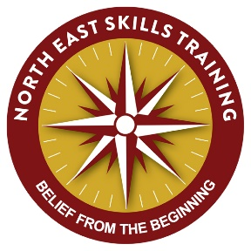
Dear Parents & Carers

YEAR 4 AFTER SCHOOL AWARDS CLUB SUMMER TERM (SLUK Playmaker)

Following on from our successful NNAS navigation provision last term we will be running an after-school Sports Leaders Award for ten sessions.

This is another fantastic opportunity for your child to start to add to their record of achievement at such an early age. NEST has been delivering this award in this and other schools for over four years now and it has been extremely well received.

This is a Sports Leaders UK Award where students learn the importance of planning, preparation and other considerations when wanting to lead their own sports sessions. All the skills learnt are transferrable to other subjects and indeed life. It is also the starting block for progressing through the SLUK syllabus which is covered in some secondary schools. If your child is interested could you please complete and return the form below before the course commences, so the necessary arrangements can be made.

For more information and to see what NEST has to offer, as well as read some testimonials please visit www.northeastskillstraining.co.uk
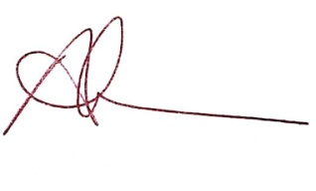

Andrew Vince

Instructor at NEST

YEAR 4 AFTER SCHOOL AWARDS CLUB 2019 (SLUK PLAYMAKER)

My child ______________________________________ would like to take part in the Y4

and Awards Club (Navigation)

Parent or guardians name: _______________________________________

Emergency contact number: ______________________________________

I enclose the payment of £45, cheques made payable to North East Skills Training or cash to the school office FAO North East Skills Training. (please note registration with and certification from SLUK costs £7 which is included in the £45)

Signed: _______________________________________(parent/carer)

Any special medical information:

Please tick this box if you do not wish your child to be included in any publicity or promotional material, names of individuals will never be used.

