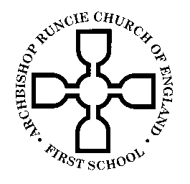
ARCHBISHOP RUNCIE CHURCH of ENGLAND (VA) FIRST SCHOOL

Year 4 Newsletter 7th January 2019

Dear Parents,

Welcome back! I hope you have had a wonderful Christmas break filled with happiness and also some relaxation! Can I take the opportunity to thank you again for such lovely gifts and cards!

This term, Year 4 will be learning all about South Africa! We will be exploring the country in a variety of different ways across the curriculum, beginning with an exciting visitor from South Africa…Mrs Durr!! I’m sure the children will be so excited to see her and to learn all about her native country of South Africa.

Children will continue to choose their own reading books in Year 4. Please remember to write a short note in your child’s Reading Record book so we know how your child is reading at home. I will put in reading challenge stickers as a target for your child with their reading if you could comment on how they have done with this at home it would be much appreciated!

Homework stickers will continue to be given out every Thursday so that the children can complete this and hand them back in on Tuesday. As discussed at the Welcome Meeting in September, we would be grateful if parents could mark their child's work and return it to school every Tuesday. This gives me an opportunity to look at each child's book on a Tuesday evening and set appropriate tasks for the following week.

PE will continue to be taught on a Thursday. PE kits should be left in school (in lockers) and should contain a pair of well-fitting plimsolls/trainers for outdoor lessons. It would be very helpful if any child with long hair could have their hair tied up in a ponytail on this day too.

A friendly reminder that children can bring in fruit or vegetables as a snack for morning break time. They will continue to bring their recorders into school. Please contact the school office if you need to organise purchasing a recorder through school.

As always there is lots to do in school…. If you have a regular slot of spare time and would like to help, we would be extremely grateful! If you have DBS clearance, and are interested in helping out, please speak to one of us! Year 4 are in particular need of some more reading buddies; if you know a relative/neighbour who might be willing to volunteer please ask them to contact school.

If you have any questions or queries please do not hesitate to catch me at the end of the school day. You can also email me at jennifer.burns@archbishop.newcastle.sch.uk. Here’s to a successful new year!

Yours sincerely,

Miss Burns

