[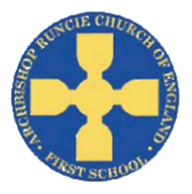](https://www.google.com/url?sa=i&rct=j&q=&esrc=s&source=images&cd=&cad=rja&uact=8&ved=2ahUKEwiSuoC5rb_cAhUF1RoKHfKcAowQjRx6BAgBEAU&url=https://www.newcastlesupportdirectory.org.uk/kb5/newcastle/fsd/service.page?id%3D8Dx9kLf4NJ0&psig=AOvVaw0hbLW86w7T2VgDezq77HoS&ust=1532783445258693)

**History**

The children will be exploring items in a time capsule from 30 years ago, carefully examining objects to help them answer questions. We will use a timeline to help to understand the chronology of events.

**‘Our School’ Autumn Term 2018 Year 1**

**Science**

In Science we will be learning about different materials, their properties and why they are chosen for different purposes. We will investigate if there are any differences in the materials used today compared to 30 years ago.

**Physical Education**

In PE this term we will continue to develop our balance, agility & co-ordination skills. We will also improve our long distance running techniques by completing the Golden Mile each week.

**Geography**

In Year 1 we will use maps to compare where the old school site was in relation to where it is now. We will ask and answer Geography questions.

**Mathematics**

We will be focusing on place value and addition and subtraction including:

* Count forwards and backwards to 20, from any number
* Count 1 more and 1 less
* compare and order numbers from 0 up to 20; use the language: equal to, more, less, greater than, less than; use <, > and = signs
* use symbols + - = to write number sentences
* begin learning number bonds to 10

**English**

In English we will be reading the Roald Dahl classic ‘Matilda’. The children will identify the main events in the beginning, the middle and end of the story. They will start to write a series of sentences to sequence events.

**Art**

We will be working with a local artist to create our own commemorative sculpture, using line, shapes and texture.

**Religious Education**

We will learn about why we are linked to two different churches – St Nicholas and All Saints.

We will learn about Harvest Festival and thanking God for his gifts.

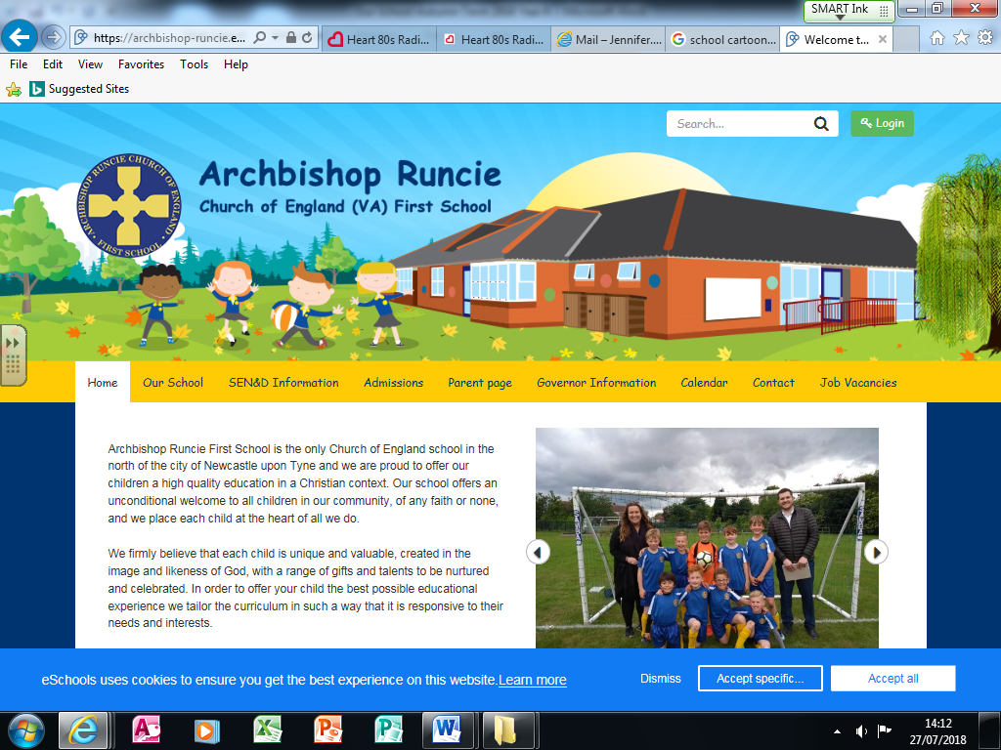

**Computing**

We will be learning to program toys by inputting a series of instructions. We will predict where the toy will go, make the toy move and spot and correct mistakes

**Music**

The children study an old school hip hop style song to learn about the differences between pulse, rhythm and pitch and to learn how to rap!

**DT**

We will take part in an enterprising project linked to our topic. As part of this we will plan, design, make and evaluate our product.