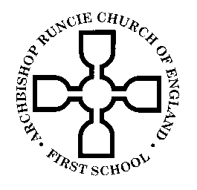
ARCHBISHOP RUNCIE CHURCH of ENGLAND (VA) FIRST SCHOOL

Year 4 Newsletter 4th September 2018
Dear Parents,

Welcome back! We hope everyone has had a lovely summer holiday and enjoyed the beautiful weather we have been having!

This September, we are very excited to be celebrating our school’s 30th Birthday and will be using this as a stimulus for our first topic this half term. Today, your children have discovered a time capsule from 30 years ago and will probably be very excited about this! Maybe they could tell you about what they discovered in the time capsule?

Children will continue to choose their own reading books in Year 4 and we have a fantastic range of new books which the children have all been so enthusiastic about! Please remember to write a short note in your child’s Reading Record book so we know how your child is reading at home. I will give your child a ‘Reading Challenge’ each week which we will also be consolidating in school during shared reading time and English lessons. Please could you ensure book bags are brought to school every day, checked for letters every night and old letters removed.

PE will usually be taught on a Monday. PE kits should be left in school (on cloakroom pegs) and should contain a pair of well-fitting plimsolls/trainers for outdoor lessons. It would be very helpful if any child with long hair could have their hair tied up in a ponytail on these days too.

Children can bring in fruit as a snack for morning break time. They will continue to bring their recorders into school. Please contact the school office if you would like to organise purchasing a recorder through school.

As always there is lots to do in school…. If you have a regular slot of spare time and would like to help, we would be extremely grateful! Some parents prefer to work with groups of children, others prefer to do jobs “behind the scenes” (changing books, laminating etc.). If you have DBS clearance, and are interested in helping out, please speak to one of us!

I look forward to meeting you at the Parents Welcome Meeting on Monday 17th September 9:00-9:30am where I will explain the Year 4 curriculum and behaviour expectations, homework and preparation for Upper Key Stage 2!

Photo consent letters will follow shortly, if you could sign them and return to the class teacher as soon as possible.

If you have any questions or queries please do not hesitate to catch me at the end of the school day. You can also email me at jennifer.burns@archbishop.newcastle.sch.uk.

I am really looking forward to working with you, and your children, in the coming year!

Yours sincerely,

Miss Burns

