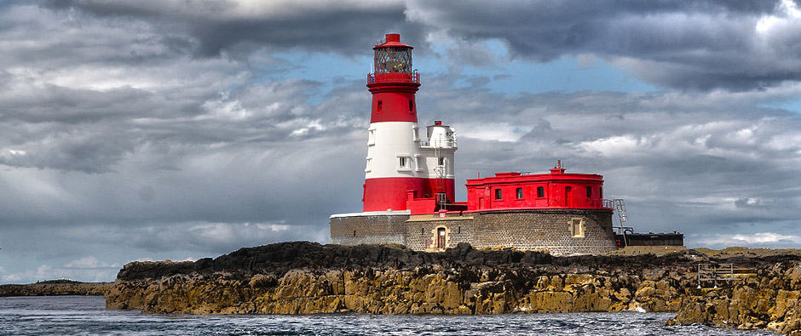
Year 2
Summer Term 1
Seaside Rescuers
Maths:
We will be completing a short unit on position and direction before moving onto telling the time where we will:
Tell and write the time to five minutes, including quarter past/to the hour and draw the hands on a clock face to show these times.
Know the number of minutes in an hour and the number of hours in a day
Compare and sequence intervals of time
ReRecognise and use symbols for pounds (£) and pence (p); combine amounts to make a particular value.
Find different combinations of coins that equal the same amounts of money.
Solve simple problems in a practical context involving addition and subtraction of money of the same unit, including giving change.cognise and use symbols for pounds (£) and pence (p); combine amounts to make a particular value.
Find different combinations of coins that equal the same amounts of money.
Solve simple problems in a practical context involving addition and subtraction of money of the same unit, including giving change.
PE: In PE we will participate in team games, developing simple tactics for attacking and defending. We will also be developing our skipping in preparation for our skipping festival.
Science: In Science, we will be exploring and comparing the differences between things that are living, dead and things that have never been alive as well as identifying a number of plants and animals in habitats. We will do this by examining the rock pool habitat.
History: We will examine the life of Grace Darling who is a significant individual in the past who has contributed to national achievements. We will do this through exploring the life and achievements of Grace Darling, as part of our local history.
Music: We will be using our voices expressively by singing songs and speaking chants and rhymes. We will use this to prepare for our “Big Sing” festival in June.

RE: We will be looking at our amazing world and who made it this half term. This will include thinking about the Christian view of creation and using the bible story to think about promises we can make to look after our world.

DT: In DT we will be creating our own masks. We will focus on cutting, shaping, joining and finishing as well as evaluating our finished product.
English: We will be exploring the structure and features of information texts around the topic of Grace Darling. We will then produce our own information texts applying the features of this genre.
Computing: In Computing, we will organize, store, manipulate and retrieve data in a range of formats. We will produce our own PowerPoint presentations linked to the seaside and animals found in a rockpool.

Art: We will use shading to draw physical and human features linked to the seaside environment.

