**Spring Term 2 Nursery**

**Religious Education**

We will be learning about the special time of Lent and the lead up to Easter.

We will continue to learn about the value of Friendship.

**Physical Development**

The children will continue to jump off an object and land appropriately and travel with confidence and skill around, under, over and through balancing and climbing equipment.

They will continue to develop their fine motor skills to support early letter formation.

**Topic: Pets**

**Literacy**

Children will be looking at a range of stories with a pet theme including Kipper’s Toybox and other Kipper books, The Bog Baby, Broken Bird, The Baby Birds, Tabby McTat and other stories. There will be opportunities to read and mark make in our Pet Grooming Station and later on Veterinary Surgery including lists, prices and appointments. We will look at a range of non- fiction texts about caring for animals and pets. We will also continue with our phonics sessions, this term we will be looking at alliteration and initial sounds.



**Exploring and using media and materials**

Children will explore a range of media and materials to create their own pet. We will explore colours and what happens when they mix colours.

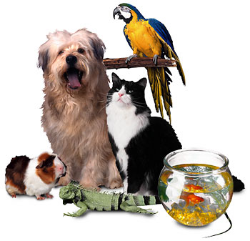

C:\Program Files (x86)\Microsoft Office\MEDIA\CAGCAT10\j0216724.wmf

**Mathematics**

Children will be learning to count out objects and match numeral and quantity in our pet shop role play. They will use lots of mathematical language in their play.

The children will continue to practise rote counting to 10, and then to 20.

**Understanding the world**

Children will take part in a range of first hand observations of animals and learn how pets differ. They will learn how to look after pets and develop a sense of stewardship towards living animal and plants. Children will explore the occupations associated with pets including vets, pet shop owners and pet grooming shop owners.

**Being imaginative**

Based on the children’s own experiences, we will engage in imaginative role-play in our ‘Pet grooming station’ and ‘Veterinary Surgery’. Children will engage in small world play building homes for pets and building up stories about pets.