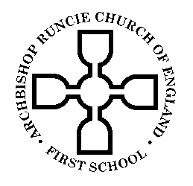
ARCHBISHOP RUNCIE CHURCH OF ENGLAND (VA) FIRST SCHOOL

PARENT & CARER COUNCIL MINUTES

Monday 4th February 2019

“For everything created by God is good, and nothing is to be rejected if it is received with thanksgiving, for it is made holy by the word of God and prayer.”
1 Timothy 4:4-5

- Welcome, prayer & introductions
Kate Massey (Headteacher, Craig Dallison (Governor & Y1 Parent), Helen Miller (Governor & Y4 parent), Greg Farrell (N, Y1 & Y2 Parent), Sarah McCrea (Y1 Parent) and Christine Halfpenny (R & Y3 Parent)

- Apologies- none
- Role of the Parent & Carer Council
It was agreed that the Parent/Carer Council was a mechanism for the school to hear the views of parents and carers. We agreed that parent/carer members should decide what is most important for the Parent/Carer Council to work on.
Action- CH to draft a communication to go to parents carers re. this meeting and routes of communication
Action- CH to set up e-mail address

- DRAFT Parent Council Policy
The draft policy was agreed with some minor changes. The policy is to be shared with parents via the school website in due course.
Action KM
- Nomination of Chair/secretary
It was agreed that Christine Halfpenny would chair the next meeting and after that we would have a rolling chair/secretary role so all members could be actively involved.
KM to take minutes today.

- Current concerns and what is working well
Concerns raised:
- Communication from Governors re. NEAT felt one sided and there was a concern about the lack of information provided about alternative options and the pros/cons of each
Action Governors to feedback to FGB
Action Chair of Govs to circulate alternative options (suggest to run past Parent Council)
- Staff changes in Y1 & Y2 and whether these were linked to NEAT- assurances were made that this was not the case
- Parents would like staff views of NEAT consultation- Govs to feedback to FGB

- Date of next meeting- Monday 4th March 9:00am
- AOB- none

“Love to learn, learn to love”
Colossians 3:23-24

