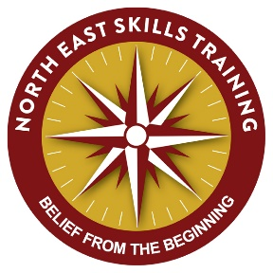

Dear Parents & Carers

YEAR 4 AFTER SCHOOL AWARDS CLUB SPRING TERM (NAVIGATION)

Following on from our successful Awards Club (1st Aid) I will be running an after-school navigation award for ten sessions starting the second Wednesday of the Spring term 330pm - 430pm.
This is an NNAS (National Navigator Award Scheme) award where your child will understand what a map is, how to use one, map concepts as well as design and use their own. The culmination of this course has the students navigating on a purpose-built orienteering course within the school grounds. If interested could you please complete and return the form below before the course commences so we can make arrangements.

Andrew Vince

Instructor at NEST

YEAR 4 AFTER SCHOOL AWARDS CLUB 2019 (NAVIGATION)

My child ______________________________________ would like to take part in the Y4

and Awards Club (Navigation)

Parent or guardians name: _______________________________________

Emergency contact number: ______________________________________

I enclose the payment of £40, cheques made payable to North East Skills Training or cash to the school office.

Signed: _______________________________________(parent/carer)

Any special medical information:

Please tick this box if you do not wish your child to be included in any publicity or promotional material, names of individuals will never be used.

DBS UPDATE SERVICE ID C6664744892

