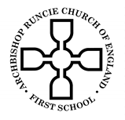 **‘Parks’ Summer Term 2 2019 Year 1**

**Science**

In Science this half term we will be learning about animals. We will look at the 5 animal groups and identify which group an animal belongs to using its key features.

**Religious Education**

This half term we will be studying the religion of Islam. This will include a visit to a local Mosque in order to understand the beliefs and practices which are important to Muslims.

**Physical Education**

In PE this term we will continue to build upon fundamental skills and movements. This will help us to prepare for sports day. As well as our regular PE lessons we will continue to complete the Golden Mile each week.

**Mathematics**

We will develop our knowledge of place value up to 100 as well as learning to tell the time and use positional language. This will include:

* Identify and represent numbers using objects and pictorial representations including the number line, and use the language of equal to, more than, less than (fewer), most and least.
* Describe position, direction and movement, including whole, half, quarter and three-quarter turns.
* Tell the time to the hour and half past the hour and draw the hands on a clock face to show these times.

**English**

In English we will be studying the stories from the Percy the Park Keeper collection. We will be building upon our knowledge of the features of a story, how characters are feeling and how an author builds excitement before writing our own version.

We will then write a non-fiction text based upon the information we have been learning about different animals. Our final week will be spent looking at a range of poetry.

[This Photo](http://en.wikipedia.org/wiki/File:Thomson_Memorial_Park.JPG) by Unknown Author is licensed under [CC BY-SA](https://creativecommons.org/licenses/by-sa/3.0/)

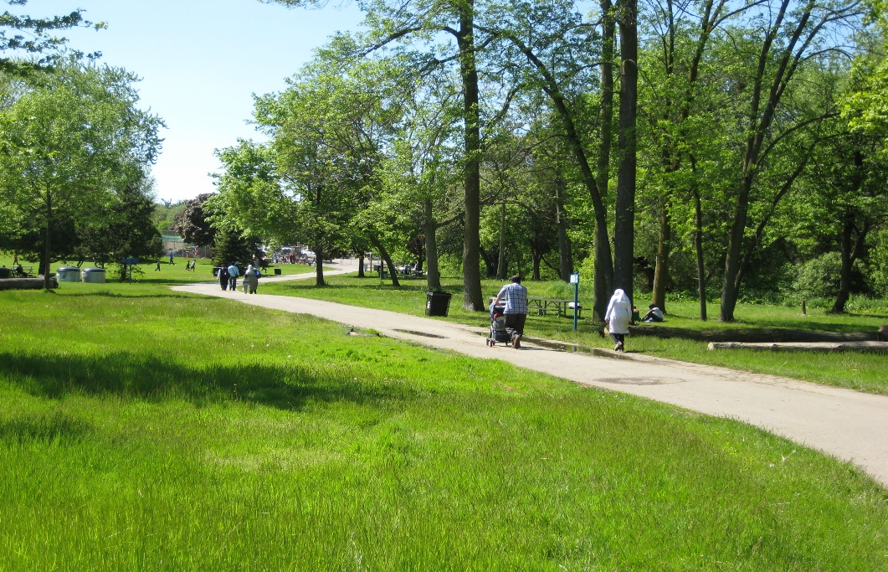

**Computing**

We will use our mouse and typing skills to access a range of programs, such as, Purple Mash and dance mat typing on the computer. We will create various pieces of work, learning to save and retrieve them.

**Geography**

We will be using fieldwork and observational skills to find out about our school and local area. This will include carrying out traffic surveys and comparing different areas of Gosforth to our school and its grounds.

**Music**

We will continue study the song ‘Your imagination’. The children have learnt to perform the song and are now ready to add instruments to the performance. This will build their skilling in keeping a beat and exploring the sounds of different insruments.

**Art**

We will explore a range of sculptures, focusing upon the work of Andy Goldsworthy. We will talk about our likes and dislikes of his sculptures, before designing and making our own Andy Goldsworthy inspired sculpture.