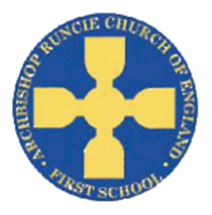
‘Roots and Shoots’ Summer Term 1 2019 Year 1
Science
In Science this half term we will be learning about plants. We will grow a variety of different plants, looking at how they grow and their key features. We will also carry out a ‘poorly plant’ experiment to find out the best way of growing healthy, strong plants.
Physical Education
In PE this term we will continue to build upon fundamental skills and movements. This will include some football skill sessions carried out by Mr Renny. As well as our regular PE lessons we will continue to complete the Golden Mile each week.
Religious Education
We will be looking at our amazing world and who made it this half term. This will include thinking about the Christian view of creation and using the bible story to think about promises we can make to look after our world.

English
In English we will be studying the traditional tale of ‘Jack and the Beanstalk’. We will be building upon our knowledge of the features of a traditional tale before writing our own version.
We then then look at the importance of clear instructions and use this information to write effective instructions of how to grow a healthy, strong plant.

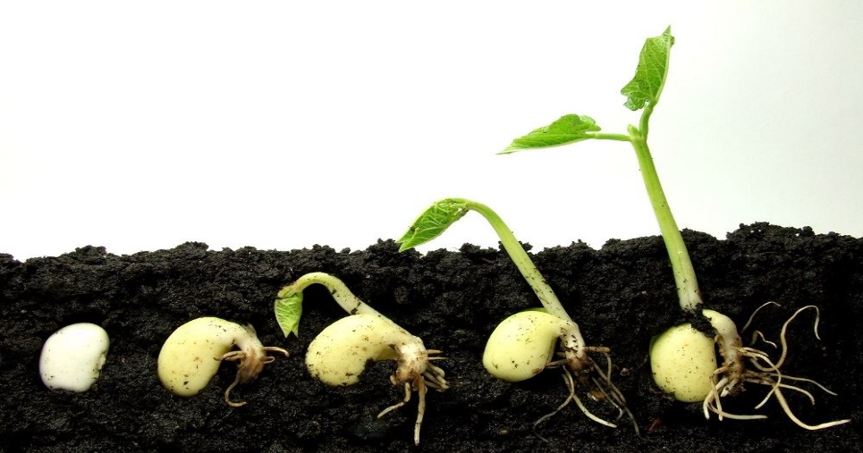
Mathematics
We will be begin looking at multiplication and division followed by fractions. This will include:
- solve one-step problems involving multiplication and division, by calculating the answer using concrete objects, pictorial representations and arrays with the support of the teacher
- identify one more and one less
- recognise, find and name a half as one of two equal parts of an object, shape or quantity
- recognise, find and name a quarter as one of four equal parts of an object, shape or quantity.

Design Technology
We create a story book of Jack and the Beanstalk. The book will use levers and sliders to make it come to life!
As we are growing our own plants we will also think about where the food we eat comes from.
Music

We will study the song ‘Your imagination’. The children will share their opinions of a range of similar style songs before learning to perform the song and add instruments to the performance.

Computing
We will be practicing our typing and mouse as well as learning how to use creative programs, save, open and retrieve our work in order to make improvements.

