[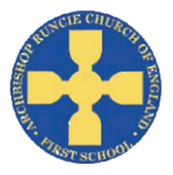](https://www.google.com/url?sa=i&rct=j&q=&esrc=s&source=images&cd=&cad=rja&uact=8&ved=2ahUKEwiSuoC5rb_cAhUF1RoKHfKcAowQjRx6BAgBEAU&url=https://www.newcastlesupportdirectory.org.uk/kb5/newcastle/fsd/service.page?id%3D8Dx9kLf4NJ0&psig=AOvVaw0hbLW86w7T2VgDezq77HoS&ust=1532783445258693)

**Geography**

We will be exploring the seas and continents of the world this half term. We will use maps, atlases and globes to label the key features, as well as exploring the United Kingdom. We will also use our map skills to draw our own simple map and give directions to get to places.

**‘Pirates’ Spring Term 2 2019 Year 1**

**Science**

In Science we will be learning about different materials and their properties. We will explore and test the properties of a range of different materials and use this knowledge to suggest suitable materials for a shipmate’s boots.

**Physical Education**

In PE this term we will be building upon our dance skills. This will involve moving in different way to different music and mirroring movements with partners. We will also have the opportunity to complete some Zumba dance sessions as well as the Golden Mile each week.

**Mathematics**

We will be continuing to focusing on place value (to 50), as well as exploring different types of measurements. This will include:

* read and write numbers from 1 to 20 in numerals and words
* identify one more and one less
* identify and represent numbers using objects and pictorial representations and use the language of: equal to, more than, less than (fewer), most, least
* measure and record length, height, weight and capacity.

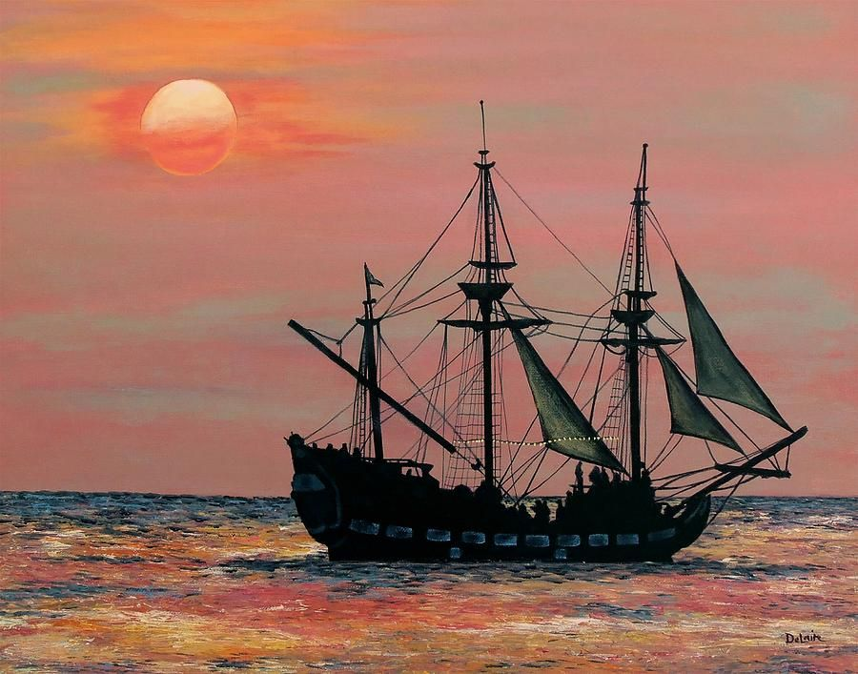

**Religious Education**

We will begin to explore the Christian idea of Salvation. This will involve looking at the Easter story and finding our Why Easter is important to Christians.

**Computing**

We will become storytellers, making our own audio book for a traditional tale. We will learn how to use creative programs, save, open and retrieve our work in order to make improvements.

**Music**

We will study a song the song ‘Round Round’ which is in a Bossa Nova Latin style. The children will share their opinions or a range of similar style songs before learning to play the sound using the glockenspiel.

**Art**

We will practice the skill of colour mixing as well as identifying primary and secondary colours. We will then look at the work of Joseph Turner before creating our own seascapes.

**English**

In English we will be studying Pirate poems. The children will identify key features such as rhymes, share their likes and dislikes as well as having the opportunity to perform the poem. We will then study the traditional tale of ‘Snow White’, before writing our own version.