**Spring Term 2 Reception**

**Physical Development**

Children will be developing a range of skills in PE through apparatus work including climbing, balancing and travelling on, over and through equipment.

Children will continue to improve their handwriting skills: looking at capital letters and numeral formation.

**Religious Education**

We will be learning about the special time of Lent and the lead up to Easter.

We will be exploring "Love" and what this means to us.

**Topic: Pets**

**Literacy**

Children will be looking at a range of stories with a pet theme including The Great Pet Sale and Bog Babies. We will be writing descriptions of our pets and keeping diaries of about the Bog Babies. There will be a wealth of reading and writing opportunities in the Pet Shop including lists, prices and appointments. We will looking at a range of non- fiction texts about caring for animals and pets.



**Exploring and using media and materials**

Children will explore a range of media and materials to create their very own bog babies. We will be creating observational drawings of living plants and animals.

**Mathematics**

Children will be learning about money in our pet shop role play. They will apply their addition and subtraction skills in the shop and begin to solve everyday problems using money. We will be exploring weight and height through pet measurements and using our data handling skills to find out about our favourite pets.

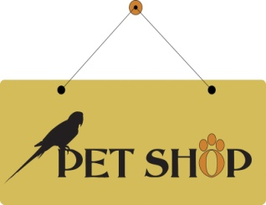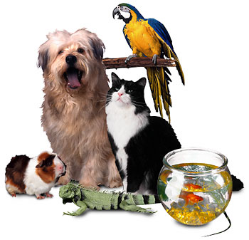C:\Program Files (x86)\Microsoft Office\MEDIA\CAGCAT10\j0216724.wmf

**Understanding the world**

Children will take part in a range of first hand observations of animals and learn how pets differ. They will learn how to look after pets and develop a sense of stewardship towards living animal and plants. We will find out where in the world our pets come from.

**Being imaginative**

Children will become adventurers in Bluebell Wood searching for Bog Babies. We will use ideas from this story to create our own role play, stories and Bog creatures. Children will explore the occupations associated with pets including vets and pet shop owners.