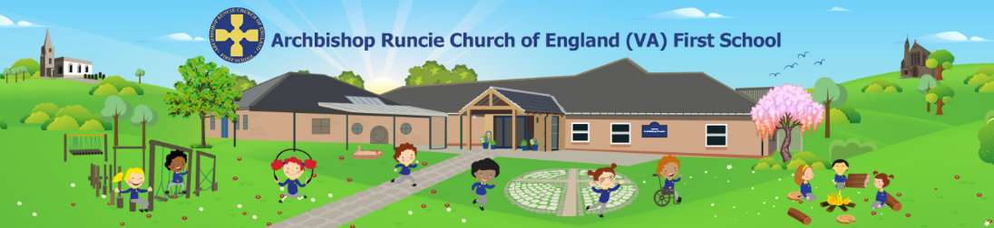

NURSERY APPLICATION FORM 2024-25

 | Deadline for application
Spring 2025 Intake  (start date: January 2025)  for children who are 3 years-old on or before 31st December 2024 | 1st November 2024

Archbishop Runcie CE First School offers 15 free hours of childcare per week (which is offered as 2½ days) and 30 hours childcare which is offered as 5 days per week, during term time. Sight of birth certificate and proof of address will be required upon application. You will need to provide sight of original documents to the school - your application and offer of a place is dependent on this.

Option 1 or Option 2 - 15 hours per week
In applying for and accepting a nursery place at Archbishop Runcie CE First School for 15 hours you are entering an agreement to use your initial 15 free hours with Archbishop Runcie CE for the entire academic year of which you have applied.

Option 3 - 30 hours per week
For those parents who are eligible for the 30 hours code: In applying for and accepting a nursery place at Archbishop Runcie CE First School for 30 hours, you are entering an agreement to use your initial 15 free hours and the additional 15 funded hours with Archbishop Runcie CE First School for the entire academic year of which you have applied. You also agree to confirm your 30 hours code by the deadline requested by Newcastle City Council or this will affect your child’s additional free 15 hour place and you will be charged the cost of the remaining 15 hour nursery place.
NB: It is your responsibility to reconfirm your 30 hour code every 3 months on the Government portal.

For those parents who are not eligible for the 30 hours code: For those who wish to purchase the additional 15 hours the cost will be £15 per half day session. Single sessions cannot be purchased.

Option 1 – 15 hours  Monday: 8.40am – 3.10pm  Tuesday: 8.40am – 3.10pm  Wednesday: 8.40am – 11.30am | Option 2 – 15 hours  Wednesday: 12.30pm – 3.10pm  Thursday: 8.40am – 3.10pm  Friday: 8.40am – 3.10pm | Option 3 – 30 hours  Full time nursery place  Monday to Friday: 8.40am – 3.10pm

It is not possible to exchange sessions within a week.

Child’s Surname: | Child’s First Name:
Child’s Date of Birth: | Gender:
Child’s Address:

Post Code:

Telephone Number: | Email Address
Parent/carer’s name:
Mr/Mrs/Miss/Ms/Other
I enclose a copy of my child’s birth certificate and proof of address: ◻

My child has attended previous settings or is currently in a setting eg, childminder, nursery, playgroup: ◻

My child has never attended a childcare setting without an adult: ◻

Agencies involved with my child e.g. NHS Speech & Lang, Early Help, Children’s Social Care:

Criteria 1- Looked After Children

Looked-after children and children who were previously looked after, but ceased to be so because, immediately after being looked after, they became subject to an adoption, child arrangements or special guardianship order. This includes children previously in state care outside of England who have ceased to be in that state care as a result of being adopted.

Is your child in public care, i.e. looked after by a Local Authority? YES / NO

Has your child previously been in public care, i.e. looked after by a Local Authority? YES / NO

If yes, which Local Authority looks after your child?
Please give the name of the social worker involved

Criteria 2- Siblings

Does your child have a sibling who currently attends Archbishop Runcie CE First School? YES / NO

Does your child have a sibling who will attend Archbishop Runcie CE First School in the year in which your child may attend? YES / NO

If yes please give details below.

Name of Sibling | Date of Birth & current Year group

Criteria 3 - Children of parents who are:-
- Active members of Gosforth, All Saints’ or Gosforth, St Nicholas’ Parish Churches, or
- Resident in either the parishes of Gosforth, All Saints’ or Gosforth, St Nicholas’ and who are active members of another Christian Church located within the parish. A letter from the relevant clergy confirming this criterion has been met must be submitted at the time of application.

Do you have a letter from your Vicar confirming that you worship regularly (at least once a month) at Gosforth, All Saints or Gosforth or St Nicholas Parish Churches or of another Christian Church located within the parish? YES / NO

Nursery Preferences

Please indicate your preference for a particular session by ticking the relevant box below.

It may not always possible to accommodate your choice. (Children must attend all sessions in the chosen option).

Option 1  Monday: 8.40am – 3.10pm  Tuesday: 8.40am – 3.10pm  Wednesday: 8.40am – 11.30am | Option 2  Wednesday: 12.30pm – 3.10pm  Thursday: 8.40am – 3.10pm  Friday: 8.40am – 3.10pm | Option 3  Full time nursery place  Monday to Friday: 8.40am – 3.10pm

Have you submitted an application to any other Nurseries? YES / NO
If yes please give names and where the nursery stands in your order of preference

School Name | Preference Position

Please note that nursery admission does not automatically guarantee a place in our Reception Year.

It should be noted that an offer of a place may be withdrawn if information supplied by you on your application is intentionally misleading or fraudulent. I have read the above and undertake to inform the school of any change of circumstances before the application deadline.

If applying under criterion 3 you must provide a letter of support from your Vicar or presiding minister.

30 Hours Per Week Funded Early Education

To determine if your child is eligible for 30 hours per week funded early education place please visit Newcastle City Council website https://www.newcastle.gov.uk/schools-and-learning/childcare/30-hours-free-childcare-working-parents-0 for information.

Your data

This data will only be used in relation to your nursery application; we will not share this information with other organisations, and will only hold this information until the end of the academic term in which you applied, unless you choose to be added to our waiting list. You can opt out of communication by contacting admin@archbishop.newcastle.sch.uk

Signed: _________________________________________

Name: __________________________________________

Date: ___________________________________________

FOR OFFICE USE ONLY
Birth Certificate Seen | Evidence of child’s home address seen | If applying under criterion 3 you must provide a letter of support from your Vicar or presiding minister. | STAFF NAME

