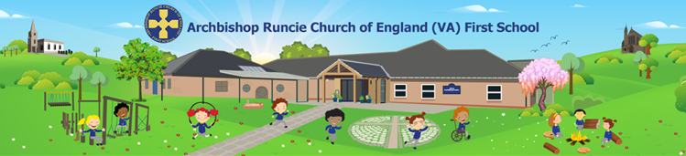

Fundamental British Values in Early Years

In the Early Years, British Values are explored in ways that are meaningful to young children often as part of a setting’s spiritual, moral, social and cultural curriculum. Fundamental British values are important democratic values. There are many people all over the world who live by democratic values. Each value represents an ideal that is important to communities across the UK. Overall, the goal of these values is to enable people to be part of a democratic society and to help them to look after others around them.

The Fundamental British Values are:

* Democracy
* The rule of law
* Individual liberty
* Mutual respect and tolerance of different faiths and belief

These values are demonstrated by:

**Democracy**

* Giving children the chance to vote for choices in activities. They might raise their hands or write down their favourite choice. Maybe they could select a favourite story or the song for group time.
* Talk about voting, for example, by visiting a polling station at an election time or role-playing voting using a ballot box.
* Offering children choices so that they have some control and power over their lives. This develops independence and making good choices is an essential life skill.
* Creating an environment which is a safe space to share ideas, consider alternative courses of action, make mistakes and try again.
* Making sure children know that their views and opinions matter. This might be done by following children’s interests when planning activities. Encourage them to make requests too.
* Encouraging children to make decisions together, for example, when sharing a large train set.
* Supporting children to understand that they are part of a family, class, group, school/setting and community.
* Encouraging children to value each other’s views and talk about their feelings, for example, during circle time activities when they might talk about their likes and dislikes.
* Offer opportunities for children to take turns, share, discuss and collaborate in a range of activities.
* Use group times and circle times to promote turn-taking, to encourage children to listen to each other and to value everyone’s contribution.

**The Rule of Law**

* Discussing why rules are needed and how they should be administered fairly so that everyone is kept happy and safe.
* Including children in creating class or group rules.
* Encouraging and supporting children with learning about right from wrong.
* Helping children to understand their own and others’ behaviour and feelings, as well as the consequences of their actions.
* Helping children understand how to keep themselves safe and how to resolve conflicts appropriately, building upto doing this independently without the support of an adult.
* Creating an environment in which actions are always followed through - so discussions are followed up, conflicts are resolved and requests are responded to.
* Encouraging children to take turns, share and cooperate.
* Giving children the opportunity to learn about the jobs of those involved with the rule of law, such as police officers.

**Individual Liberty**

* Providing opportunities to develop children’s self-esteem and confidence in their own abilities.
* Encouraging them to develop a positive sense of themselves and to celebrate their personal achievements. Linked to school values of Love and Determination.
* Motivating children to ask questions. Ensuring they know that their questions, ideas and opinions will be valued and respected.
* Enabling children to take on challenges, risks and responsibilities, showing perseverance and resilience.
* Encouraging children to explore their thoughts and feelings with those that they trust and offer them the vocabulary to help them to do this. (linked to colour monsters, zones of regulation)
* Allowing children to develop their independence, offering them opportunities to follow their own ideas and interests.
* Ensuring that all children engage in a wide range of activities and are not limited by gender or other stereotypes.
* Encouraging children to express their own views and also respect the fact that others may have different views.

**Mutual Respect and Tolerance of Different Faiths and Beliefs**

* Encouraging children to reflect on their similarities and differences with each other and foster an inclusive approach.
* Creating an environment that includes, values and respects different faiths, cultures, views and ethnicities.
* Providing opportunities to make links with the local community, for example, outings to local places (such as shops or places of worship), inviting members of the local community to visit the school, taking part in local events and making links with a local charity.
* Encouraging children to see themselves as part of a wider community. They learn about national commemorations, such as Remembrance Day. They could also learn about places around the world using a range of resources, including books and online resources.
* Helping children to learn about other faiths, cultures, traditions, families, communities and ways of life and to be curious and appreciative. Encouraging children to share their own experiences and respond to the experiences of others. They might learn about festivals and special days, different types of family units and different occupations. (embedded in RE curriculum and everyday practice)
* Encourage children to appreciate similarities as well as differences, helping them to build constructive and respectful relationships.