**Summer Term 1 Nursery**

**Physical Development**

The children will continue to jump off an object and land appropriately and travel with confidence and skill around, under, over and through balancing and climbing equipment.

We will practise handwriting patterns on the big easels outside and continue to develop our fine motor skills to support early letter formation. We will also look at healthy eating.

**Religious Education**

We will be learning about prayers and talking about how we pray. We will hear the Christian family prayer ‘The Lord’s Prayer’. We will find out how people of other faiths pray.

**Topic: On the Farm**

**Literacy**

Children will be looking at a range of stories with a farm theme including What the Ladybird Heard, Buster’s Farm, Farmer Duck and a traditional tale The Three Little pigs. There will be opportunities to read in our reading corner and mark make both inside and outside. We will look at a range of non- fiction texts about farms and caring for farm animals. We will also continue with our phonics sessions, this term we will be looking at voice sounds and initial sounds. They will continue to practise recognising their own name and begin to write it.

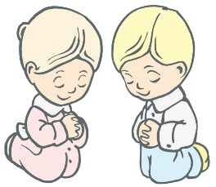

**Exploring and using media and materials**

Children will explore a range of media and materials to create their own shoebox diorama of farm animals or the traditional tale ‘The Three Little Pigs’. We will paint our favourite farm animal.

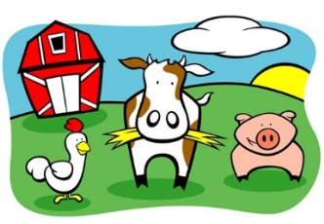

**Mathematics**

Children will continue to learn to count out objects and match numeral and quantity. They will begin to order two or three items by length or height. The children will use some language related to money in their play in our Farm Shop outside.

We will continue to practise rote counting to 10, and then to 20.

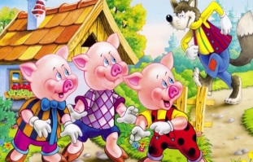

**Being imaginative**

Based on the children’s own experiences, we will engage in imaginative role-play in our ‘On the Farm’ area and in the ‘Farm Shop’ outside. Children will engage in small world play building homes for farm animals and building up stories around farm life. They will also act out and retell the story of ‘The Three Little Pigs’.

**Understanding the world**

**We will be investigating the farm environment and talking about the animals and people who live and work on the farm. We will look at where our food comes from and how some of it is grown.**