**Personal, Social and Emotional Development**

I will be;

* talking about how my actions may affect others.
* discussing the behaviour of the step sisters in the story Cinderella and thinking about how this made Cinderella feel.
* I will think about what I would do with a wish from a fairy godmother

**Literacy**

I will be;

* reading the texts Cinderella and Dinosaur Roar
* looking at non fiction books about dinosaurs.
* beginning to hear the initial sounds in words.
* continuing to copy letters from my name and begin to write it independently.

**Characteristics of Effective Learning**

I will be;

* finding out and exploring.
* willing to have a go.
* playing with what I know.
* being involved and concentrating.
* enjoying achieving.
* persistent and keep on trying.
* sharing my own ideas.
* making links.
* choosing ways to do things.

**Mathematics**

I will be;

* reciting numbers to 10.
* looking at 2d shapes and using these to make Cinderella’s castle.
* looking at the clock and talking about time e.g. midnight.
* grouping dinosaurs by similarities

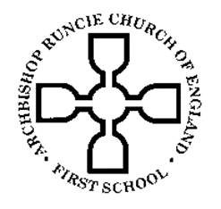

**Communication and Language**

I will be;

* listening to instructions and responding appropriately.
* learning new words and their meanings such as archaeologists, excavate, carnivore, herbivore’ Jurassic, ball and coach.
* talking about my favourite dinosaur and give reasons for my choice.

Nursery

Spring Term 1

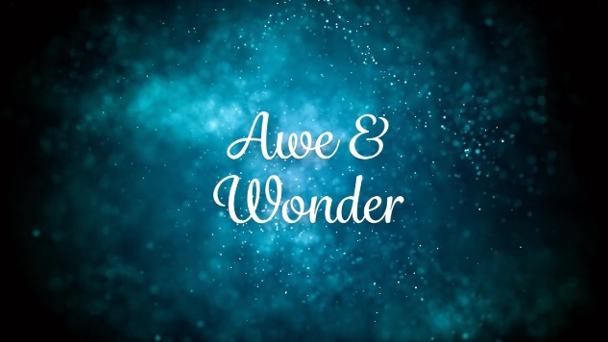

**Understanding the World**

I will be;

* discussing why dinosaurs are no longer here.
* learning how to stay safe on the internet.
* engaging in scientific experiments.

**Expressive Arts and Design**

I will be;

* re-enacting the story of Cinderella with puppets.
* making and decorating a crown
* using the wax resist technique to create enchanting pictures.
* making paper mache dinosaurs and their eggs.

**Physical Development**

I will be;

* excavating dinosaur bones and begin to rebuild a skeleton.
* getting dressed and undressed independently for P.E and I will using the climbing equipment.
* dancing at Cinderella’s ball.
* moving like a Dinosaur and thinking about how different dinosaurs moved.
* making Fairy Godmother fruit kebabs and talking about healthy foods.

“Love to learn, learn to love.”

**Religious Education**

I will be;

* learning all about the Creation story
* celebrating Chinese New Year.

**Visits and Visitors**

I will be;

* visited by the Road Safety Officer and learn all about how to stay safe.