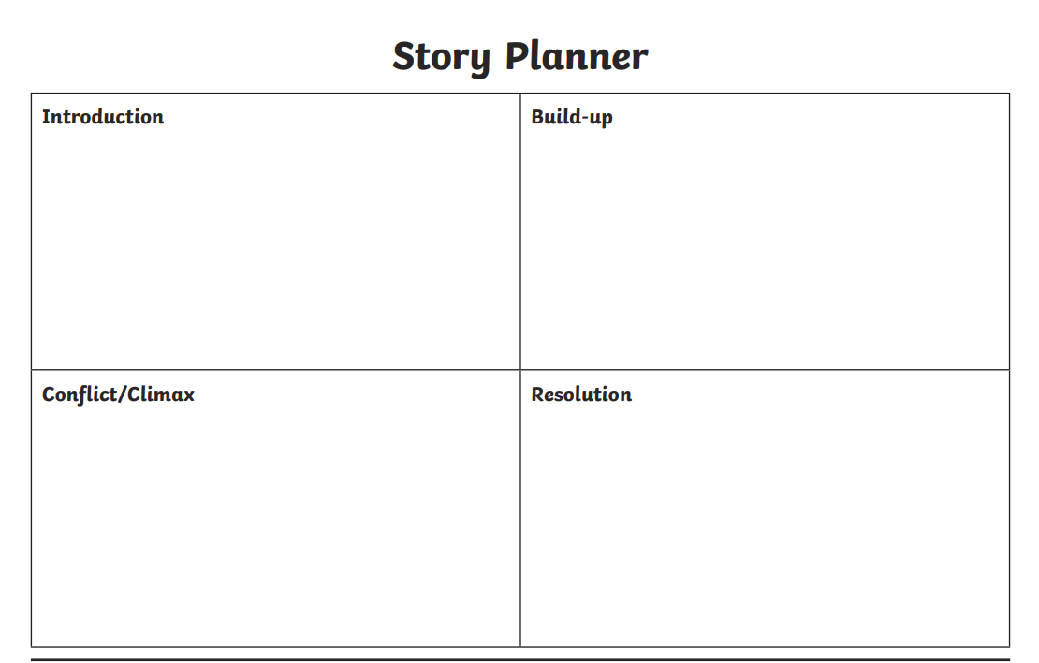

**Advertising Poster Plan**

**Any other details**

**About Vincent Van Gogh** (Why is he famous?)

**Art** (Which piece of art? Why?)

**Location** (Which gallery? Where is it in the world?)