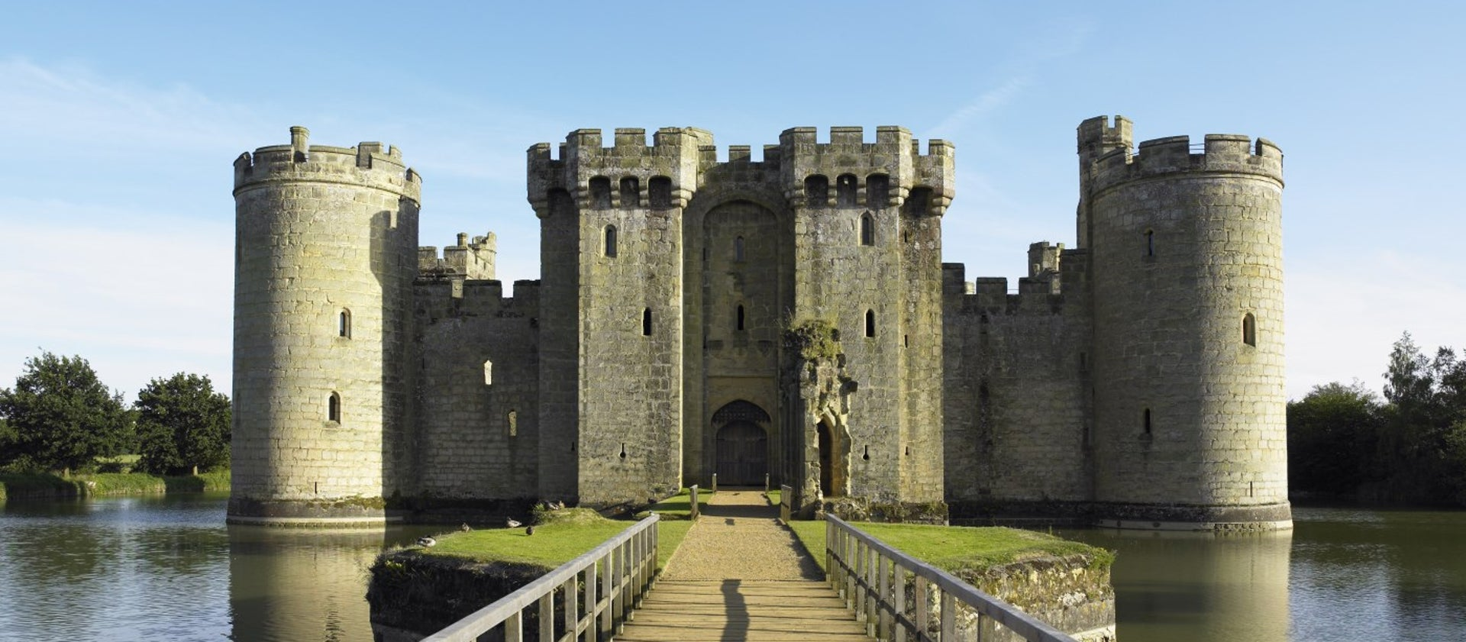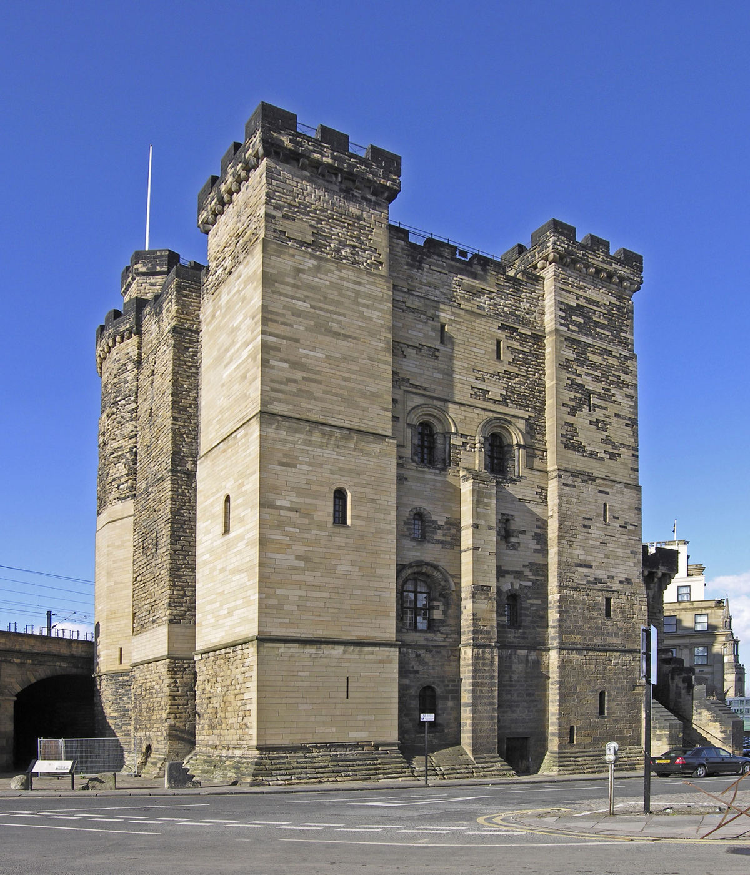
Year 2
Spring Term 1
Castles
Maths:
We will be starting our multiplication and division unit.
recall and use multiplication and division facts for the 2, 5 and 10 multiplication tables, including recognising odd and even numbers
calculate mathematical statements for multiplication and division within the multiplication tables and write them using the multiplication (×), division (÷) and equals (=) signs
show that multiplication of two numbers can be done in any order (commutative) and division of one number by another cannot ▪ solve problems involving multiplication and division, using materials, arrays, repeated addition, mental methods, and multiplication and division facts, including problems in contexts.
Our next unit will be fractions.
ReRecognise and use symbols for pounds (£) and pence (p); combine amounts to make a particular value.
Find different combinations of coins that equal the same amounts of money.
Solve simple problems in a practical context involving addition and subtraction of money of the same unit, including giving change.cognise and use symbols for pounds (£) and pence (p); combine amounts to make a particular value.
Find different combinations of coins that equal the same amounts of money.
Solve simple problems in a practical context involving addition and subtraction of money of the same unit, including giving change.
PE: In PE, we will be taking part in team games. We will be learning how to attack and defend in a game of volleyball.

Science: In Science, we will be investigating everyday materials. We will be experimenting properties of materials and how materials change shape. After these experiments, we will be deciding materials to use when designing an object and explain why.
History: In History, we will be focussing on the chronology of Castles. We will be making timelines and discussing what life may have been like then and why. We will then be looking at two local castles to think about what it was like to live in Newcastle Castle during different time periods. After our visit to Newcastle Castle, we will be identifying features of castles.

RE: In RE, we will be answering the question ‘What is the good news Jesus brings?’ During this unit, we will be deciding what forgiveness and peace is. The children will be identifying areas in Church and school that they can be forgiven or go to find peace. Throughout the unit we will also be reading passages from the Bible.

Art: In Art, we will be developing our drawing skills. We will be looking at how artists use drawing to create texture through lines.
English: In English, we will be studying the traditional tale of Thumbelina. We will be analysing the features of a traditional tale. Once we understand the key features, we will re-write the tale of Thumbelina then we will innovate the story.

Music: We will follow instructions on how or when to sing or play a recorder. We will make and control long and short sounds, using our voice and recorders.

