[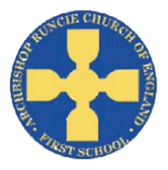](https://www.google.com/url?sa=i&rct=j&q=&esrc=s&source=images&cd=&cad=rja&uact=8&ved=2ahUKEwiSuoC5rb_cAhUF1RoKHfKcAowQjRx6BAgBEAU&url=https://www.newcastlesupportdirectory.org.uk/kb5/newcastle/fsd/service.page?id=8Dx9kLf4NJ0&psig=AOvVaw0hbLW86w7T2VgDezq77HoS&ust=1532783445258693)

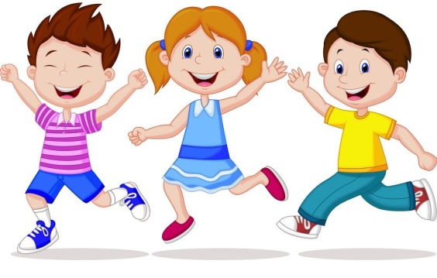 **‘All About Me’ Autumn Term 2018 Reception**

**Characteristics of effective learning**

I will be:

*Finding out and exploring *Willing to have a go *Playing with what I know

*Involved and concentrating *Enjoying achieving *Persistent and keep on trying

*Sharing my own ideas. *Making links *Choosing ways to do things

**Communication and Language**

I will be:

*Learning to follow instructions.

*Taking part in circle time activities.

*Recreating roles of real life family situations and fictional stories.

*Exploring the meaning and sounds of new words.

*Learning how to describe myself.

*Asking questions to find out about my new friends.

*Talking about my family and friends.

*Thinking about the sequence of events in stories.

**Mathematics**

I will be:

*Counting, recognising and ordering numbers.

*Learning the touch and move process for counting.

*Matching numerals to objects.

*Using estimation.

*Naming and describing 2D shapes.

*Creating repeated patterns.

*Making 3D models.

*Exploring characteristics of everyday objects.

**Literacy**

I will be:

*Linking sounds to letters.

*Hearing and saying initial sounds in words.

*Learning to write my name.

*Beginning to read simple words.

*Give meaning to the marks I make.

* Writing labels, captions and lists.

*Writing identifiable letters.

**Personal, Social and Emotional Development**

I will be:

*Learning to create class rules with my friends.

*Participating in turn taking games.

*Trying and selecting new activities independently.

*Learning the routines of the school day.

*Gaining confidence to talk within a large group.

*Learning about friendship and how to value and respect others.

*Discussing my likes and dislikes.

**Religious Education**

This term in RE we will be learning all about harvest and special people.

I will be:

*Gaining understanding of the world and where food comes from.

*Exploring the value of being thankful.

*Starting my journey of choosing who will inspire and influence me.

**Physical development**

This term in PE we will be focusing on ‘games’.

I will be:

*Getting dressed independently for P.E.

*Negotiating space.

*Building on throwing skills.

*Using control and co-ordination.

*Using a pencil effectively.

*Gaining understanding for the need of variety in my diet.

**Learn to love, love to learn.**

**Knowledge and understanding of the world**

I will be:

*Talking about similarities and differences between me and my friends.

*Learning about my senses and using them to investigate.

*Finding out about different parts of the body.

*Talking about where I live and who I live with.

**Expressive Arts and Designs**

I will be:

*Exploring different sounds instruments make.

*Using a range of media to make marks.

*Painting self-portraits using mirrors.

*Naming and mixing colours.

*Designing and building a model.

*Role playing different scenarios with my friends.

Love to Leatr