[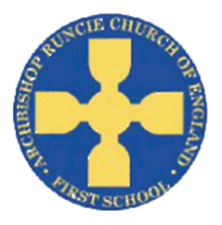](https://www.google.com/url?sa=i&rct=j&q=&esrc=s&source=images&cd=&cad=rja&uact=8&ved=2ahUKEwiSuoC5rb_cAhUF1RoKHfKcAowQjRx6BAgBEAU&url=https://www.newcastlesupportdirectory.org.uk/kb5/newcastle/fsd/service.page?id%3D8Dx9kLf4NJ0&psig=AOvVaw0hbLW86w7T2VgDezq77HoS&ust=1532783445258693)

**History**

We will explore the history of space, and find out why we remember Neil Armstrong. We will also investigate the British astronaut Tim Peake and use our historical skills to compare Neil Armstrong’s trip to space with Tim Peake’s.

**‘Space’ Spring Term 2019 Year 1**

**Science**

In Science we will be learning about the parts of the human body. We will explore which parts of the body are used for our 5 senses. We will then use this knowledge to carry out experiments using our senses.

**Physical Education**

In PE this term we will be improving and building upon our fundamental movement skills. This will involve moving in different way and using these movements to support skills such as throwing and catching. We will continue to complete the Golden Mile each week.

**Mathematics**

We will be continuing to focusing on addition and subtraction, as well as exploring different types of measurements. This will include:

* using symbols + - = to write number sentences
* read and write numbers from 1 to 20 in numerals and words
* use number bonds and related subtraction facts within 20
* measure and record length, height, weight and capacity.

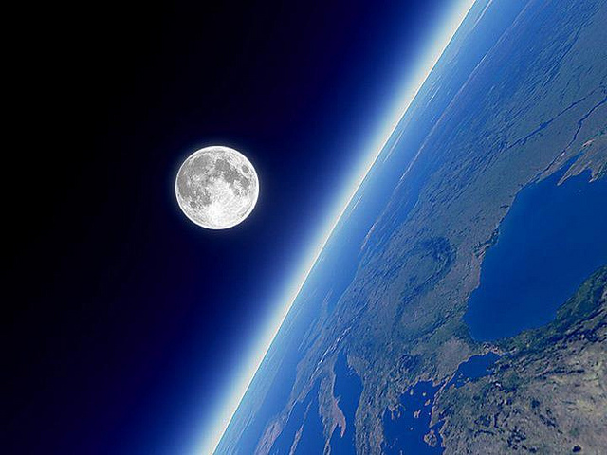

**Religious Education**

We will learn about Christianity and explore time through the Bible.

We will begin to think about the good new Jesus brought and shared.

**Computing**

We will become artists, making our own illustration for traditional fairy tales. We will learn how to use creative programs, save, open and retrieve our work in order to make improvements.

**Music**

We will study a song produced in six different styles; Blues, Baroque, Latin, Bhangra, Folk and Funk. The children will share their opinions of the songs/styles as well as learning to preform them.

**Design Technology**

To become a space explorer we need to build a space buggy. We will investigate the important features of a space buggy, design our own and finally build a prototype, using axles and wheels.

**English**

In English we will be reading ‘The Darkest Dark’. The children will begin to compare different settings from the story. We will then explore the story, building on our sentence writing skills and producing our own story setting based on ‘The Darkest Dark’.