[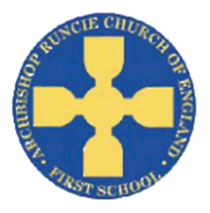](https://www.google.com/url?sa=i&rct=j&q=&esrc=s&source=images&cd=&cad=rja&uact=8&ved=2ahUKEwiSuoC5rb_cAhUF1RoKHfKcAowQjRx6BAgBEAU&url=https://www.newcastlesupportdirectory.org.uk/kb5/newcastle/fsd/service.page?id%3D8Dx9kLf4NJ0&psig=AOvVaw0hbLW86w7T2VgDezq77HoS&ust=1532783445258693)

**History**

The children will be exploring a range of toys from the past. We will investigate the different eras which the toys come from before comparing them to toys from the present. We will then make comparisons between the different materials used, before designing a toy from the future.

**‘Toys’ Autumn Term 2018 Year 1**

**Science**

In Science we will be learning about the different seasons. We will explore the changes which happen over the years, looking at different types of weather and how the length of days varies.

**Physical Education**

In PE this term we will be working on our movements skills by trying different movements and building them into different dances. We will continue to improve our long distance running techniques by completing the Golden Mile each week.

**Mathematics**

We will be continuing to focusing on addition and subtraction, as well as exploring shape. This will include:

* comparing and ordering numbers from 0 up to 20; using the language: equal to, more, less, greater than, less than; use <, > and = signs
* using symbols + - = to write number sentences
* beginning to learning number bonds to 10
* Finding the properties of 2D and 3D shapes

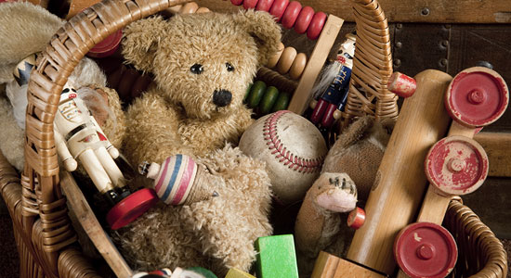

**Religious Education**

We will learn about Christianity and explore time through the Bible.

We will also be thinking about Christmas and why it is important to Christians.

**Art**

We will continue to look at different toys and complete observational drawings. We will explore how to use different lines and textures in order to create a range of drawings.

**English**

In English we will be reading ‘Lost in the Toy Museum’. The children will make predictions about the text, using the front cover for ideas. We will then explore the story, building on our sentence writing skills and producing our own ‘Lost in the Museum’ story.

**Music**

The children will study a Reggae style song as well as another hip hop style song to learn about the differences between pulse, rhythm and pitch. The children will share their opinions of the songs as well as learning to preform them.

**Computing**

We will become TV Chefs, using the Ipads to film each other making a simple healthy snack. To do this we will be learning how to give clear short instructions in order for someone else to follow the steps.