WW2

VE day

VE day stands for victory in Europe day. It took place on 8th May 1945. This is when the Allies (Britain, France, America, Russia) won the war in Europe. This was not the end of the war as Japan was still fighting. To celebrate victory in Europe they had music, dancing and bonfires. People were not allowed bonfires for 6 years during the war as this would have shown where they were. Winston Churchill and the Royal Family stood on the balcony of Buckingham palace. Queen Elizabeth and her sister stood in the crowd and nobody noticed her. Queen Elizabeth’s sister Margaret said it was the happiest moment of her life. VE day was the day after they controlled Europe.

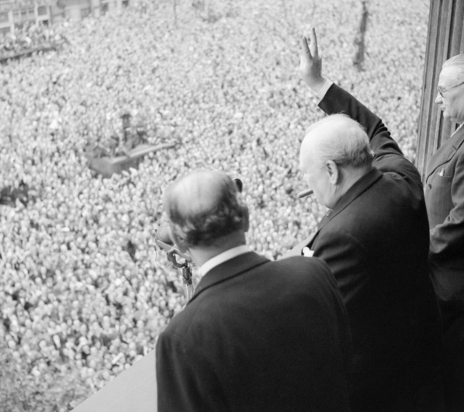

VJ day

VJ day stands for victory over Japan day. This took place on 15th August 1945. This meant that Europe had won the war overall. VE day and VJ day mark the end of hostilities.

this is VJ day 2019

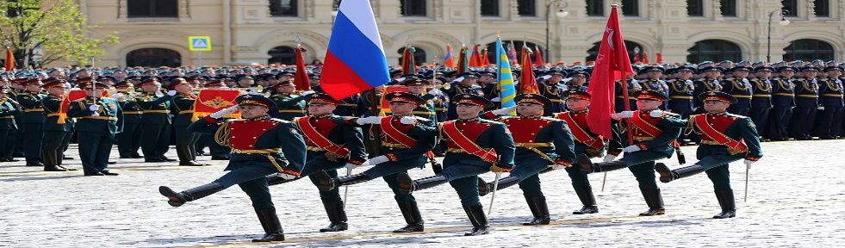

[This Photo](https://en.wikipedia.org/wiki/2018_Moscow_Victory_Day_Parade) by Unknown Author is licensed under [CC BY-SA](https://creativecommons.org/licenses/by-sa/3.0/)

Quick Facts

* The US created a new weapon called the atomic bomb
* The atomic bomb was used in August 1945 on the city of Hiroshima
* The atomic bomb was also used on Nagasaki
* Rationing continued for 10 years after the war. Below is a photo of my Great Grandpa’s petrol rationing book and my Grandpa’s identity card.

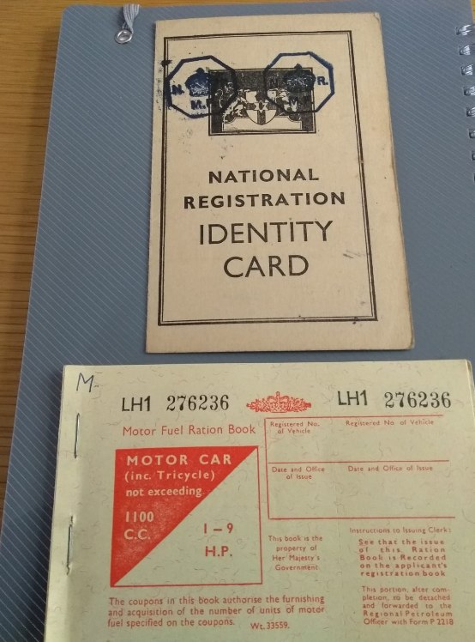

Post War Celebrations

A year after the war ended King George VI sent every boy and girl the below letter. Below is my Grandpa’s. It is really important that we remember the world wars because all the people fought for us and without them we would have more wars. These people showed great courage and strength during the war and we can learn a lot from this. That is why we should celebrate 75 years of VE day.

