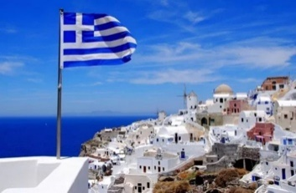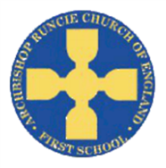

**Computing**

We will continue to use code.org to further hone our coding skills whilst also using Microbits to programme physical devices.

**Why is Greece great today? Year 4 Spring 1 2020**

**Mathematics**

We will be focusing on perimeter, area and fractions, including:

* convert between different units of measure
* measure and calculate the perimeter of a rectilinear figure (including squares) in centimetres and metres
* find the area of rectilinear shapes by counting squares
* recognise and show, using diagrams, families of common equivalent fractions
* solve problems involving increasingly harder fractions to calculate quantities, and fractions to divide quantities, including non-unit fractions where the answer is a whole number
* Add and subtract fractions with the same denominator

As always, we will continue to work on our times tables ahead of our statutory test in June. Please continue to practise at home using Times Table Rock Stars!

**Geography**

We will begin by looking at where Greece is located, its physical geography and its climate.

We will build this up to how the location affects how people live there.

The end point is for the children to understand why Greece is such a popular tourist destination and the effect this has on the country, before using our geographical knowledge next term to understanding Ancient Greece.

**Religious Education**

We will be looking at Incarnation, specifically the idea of the Holy Trinity and Baptism within the Christian faith, and examining both Gospels and Epistles.

**English**

We will begin by looking at a range of non-fiction sources, from maps to travelogues, before producing our own non-chronological report about Greece’s location.

We will then move onto fables, comparing them to fairy tales from Autumn 1 and preparing us for Greek myths next half-term.

**Physical Education**

We will, using our gymnastics work for earlier last year, look at dance and make up our own routines using a range of movements.

**Science**

Our focus for Science is sound. We will, through experimentation, recognise that sound is carried through vibrations, examine how objects have different pitches, and understand how and why sound becomes fainter the further away it is.

**Design and Technology**

In D.T., we will build upon our previous work on seasonality by looking at healthy food choices and linking this with our Greek topic, examining how Greece’s geography affects its food, what Greek cuisine is like, and what examples there are of healthy food choices within this topic. We will design a healthy Greek meal at the end.

**Spanish**

The children will work on numbers up to 40, the alphabet and days of the week.

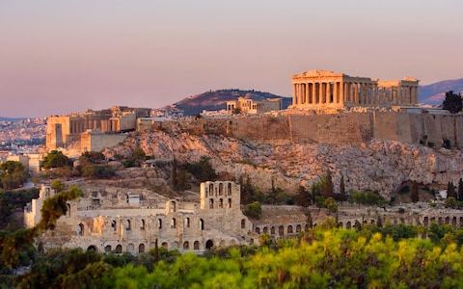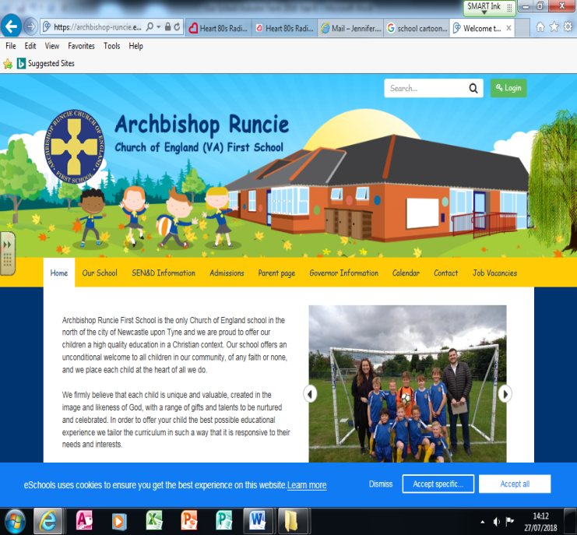

**Music**

The children will, after some initial work on their recorders, work with the Newcastle Music Service on ukuleles and play a range of different tunes.

**Personal, Social and Emotional Development (PSED)**

We will consider about how we aim high and strive towards bettering ourselves in all walks in life.