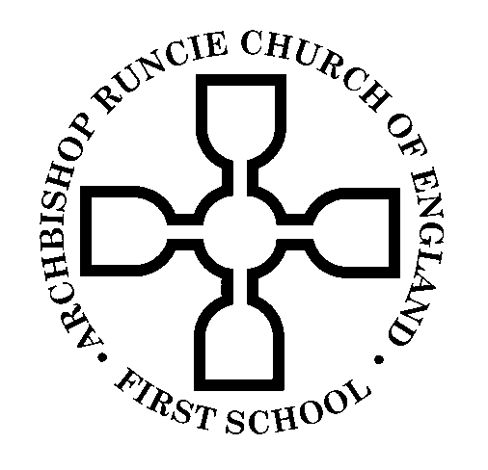
Nursery Admissions Policy
2019-2020

School Ethos Statement
“In recognition of its historic foundation, the school will preserve and develop its religious character in accordance with the principles of the Church of England and in partnership with the Church at parish and diocesan level.
The school aims to serve its community by providing an education of the highest quality within the context of Christian belief and practice. It encourages an understanding of the meaning and significance of faith, and promotes Christian values through the experience it offers to all its pupils.”
We ask all parents/carers applying for a place here to respect this ethos and its importance to the school community. This does not affect the right of parents/carers who are not of the faith of this school to apply for, and be considered for, a Nursery place.
The Governing Body of Archbishop Runcie Church of England (Voluntary Aided) First School is the Admissions Authority for the Nursery and they intend to admit up to 26 pupils (full time equivalent places) to the Nursery Class. This arrangement follows consultation between the Governing Body, the Newcastle Diocesan Education Board, Newcastle Local Authority, all other Nurseries in the area and all other Admissions Authorities in the area.
The Nursery is open to receive applications for admissions from the parents/ carers of all children. We are required by law to admit pupils with an Education, Health and Care plan or statement of special educational needs naming the School. In the event of the number of applications exceeding the number of places available, priority will be given to applications in the order of priority indicated below.

Children who will have reached their third birthday on or before 31st August of the year they are to be admitted are entitled to apply for a place at a nursery school or nursery class.
Option 1: 2 ½ days
Monday 9:00am-3:10pm (including school lunch)
Tuesday 9:00am-3:10pm (including school lunch)
Wednesday 9:00am- 12:00

or

Option 2: 2 ½ days
Wednesday 12:15pm- 3:15pm
Thursday 9:00am-3:10pm (including school lunch)
Friday 9:00am-3:10pm (including school lunch)

or

Option 3: Parents who are entitled to 30 hours free childcare will be offered 9:00am-3:10pm daily.

Parents who are entitled to 15 hours will be able to purchase additional time at the rate of £15.00 per half day or £28 per full day (including school lunch).
Over-subscription Criteria
1. Looked after children (Children who are in the care of the Local Authority (LAC)) or previously Looked After Children.
2. Children with a sibling at the school at the time of admission.
3. Children of parents / carers who have provided a letter from their Vicar confirming that they worship regularly (at least once a month) at Gosforth, All Saints or Gosforth, St Nicholas Parish Churches.
4. Children of parents/carers of other Christian denominations, or others faiths or no faith
Evidence Required
Evidence will need to be provided prior to the closing date in respect of each of the following oversubscription criteria:-
Category 1 - Parents/carers seeking admission under criterion 1 must provide evidence of the relevant order.
Category 2 - Sibling evidence will need to be provided and will be checked.
Category 3 Parents/carers seeking admission under criterion 3 must, before the closing date, provide the school with a letter signed by the Vicar of the church in question showing that their application satisfies the criterion.
If the relevant evidence is not provided to the school before the closing date, the application will be considered under criterion 4 of the over-subscription criteria.
Tie Breaker
Where there are places available for some but not all applicants within a particular criterion, distance from home to school will be the deciding factor. Distance will be measured in miles using a straight line from the centre point of the child’s address to the middle of the school using the Newcastle Maps online (the Local Land and Property Gazetteer) or a suitable alternative geographical information system, with those living closer to the school receiving the higher priority. Applications from outside the local authority area covered by this system will be measured in miles using a straight line from the centre point of the child’s address to the middle of the school on an ordnance survey map of the area. If two or more children are equidistant from the School random allocation will be used to decide who has the highest priority for admission.
Home Address
It is the child’s address which will be used in applying the admissions criteria. This means that the child’s address, at the time of application, should be used. The address of childminders (or other family members who share in the care of your child) should not be used. If offered a place, you will be asked for proof of the child’s address e.g. child benefits statement, medical card.
Waiting Lists
If we are not able to offer your child a place, the school will keep your child’s name on a waiting list for the Autumn term i.e. until the end of December 2019. If you wish to remain on the waiting list for a place in the Nursery class from January 2020 onwards, you will need to re-apply before the start of every school term using the Local Authority’s In Year Admissions application form. Waiting lists are cleared termly. A child’s position on the waiting list will be determined in accordance with the oversubscription criteria.
Right of Appeal
There is no statutory right of appeal for parents/carers who are refused a Nursey Place.
Admission to Reception
Nursery admissions are an entirely separate process (see separate Admissions Policy). Parents are asked to note that attendance at the school’s Nursery does not guarantee a place in the Reception class.
False Information
Where the Governing Body has made an offer of a Nursery place based on fraudulent and intentionally misleading information from an applicant the offer will be withdrawn.
Process
Written applications and offers for admission, either on-line or written, must be returned to the school by midday on 22nd March 2019. Places will then be allocated by strict application of the above criteria, with no reference to the date of application. Applications received after the closing date will be classified as late and considered after all of the other applications.
The school will notify parents as to whether or not their child has been allocated a place by letter posted on a date to be specified by the Gosforth Schools Trust (29th March 2019).
Places must be accepted by 26th March 2019.

Signed by the Chair of Governors Sarah Hawkins
Dated 29th January 2018

Looked after children include any child who is in the care of the Local Authority in accordance with section 22 of the Children Act 1989.
Previously looked after children include any children who were looked after children, but ceased to be so because they were adopted (or became subject to a child arrangements order or special guardianship order).
Sibling refers to brother or sister, half brother or sister, adopted brother or sister, step brother or sister, or the child of the parent/carer’s partner where the child for whom the school place is sought is living in the same family unit at the same address as that sibling.

