[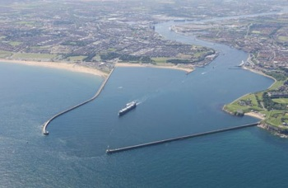](http://www.google.co.uk/url?sa=i&rct=j&q=&esrc=s&source=images&cd=&cad=rja&uact=8&ved=0ahUKEwjt2bXH7r_TAhWDDcAKHUgFA3EQjRwIBw&url=http%3A%2F%2Fwww.thejournal.co.uk%2Fnews%2Fnorth-east-news%2Fstill-guarding-river-tyne-century-4468517&psig=AFQjCNGxmxRpwI6GUSgxDVy5RHARsyYq_g&ust=1493218505974278)[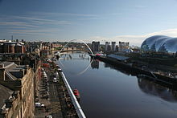](https://www.google.co.uk/url?sa=i&rct=j&q=&esrc=s&source=images&cd=&cad=rja&uact=8&ved=0ahUKEwjW7Jua7r_TAhWsCsAKHXaLAsUQjRwIBw&url=https%3A%2F%2Fen.wikipedia.org%2Fwiki%2FRiver_Tyne&psig=AFQjCNGgMlOoWWoRzoysdj2YBWQ_6a8ygA&ust=1493218231049411)

Key Stage Two

**Why is the Tyne so important?**

Summer Term 1

**English:** We will read a range of fiction and non-fiction texts on rivers then write in the style of the books that we have read. Our class novel is ‘Storlax’ and we will investigate the text and use it to inspire our own writing.

**Maths**: We will cover the following areas:

* Multiplication & division
* Fractions
* Statistics
* Addition & subtraction
* Measurement (length and time)

Please see classroom doors for further information about the weekly maths objective.

**PE:** In PE this term we will continue to develop our balance, agility & co-ordination skills. We will apply basic principles of attacking and defending in a range of games.

**Computing:**

In Year 3 we are learning to be network engineers. We will find out about how messages are sent around the world.

In Year 4 we are learning to be HTML editors. We will find out about the language in which web pages are written.

We will research an aspect of rivers and create our own leaflets.

**Science**: We will learn about rocks and soils. We will investigate the properties and uses of different rocks. The children will design their own experiments to investigate these properties.

**DT:** We will make our own pop-up books linked to the water cycle.

**Art:** We will be learning how to use batik. We will use ‘The Great Wave’ by Katsushika Hokusai as inspiration to explore colour and form.

**Geography:** We will investigate how rivers play an important role in the water cycle. We will use key vocabulary such as evaporation, condensation and precipitation. We will continue toidentify the position and significance of latitude, longitude, Equator, Northern Hemisphere, Southern Hemisphere, the Tropics of Cancer and Capricorn, the Prime/Greenwich Meridian and time zones. We will use 8 points of a compass, four and six-figure grid references, symbols and keys. Finally, we will use fieldwork to observe, measure, record and present the human and physical features in the local area using a range of methods, including sketch maps, plans and graphs and digital technologies

**Personal, Social, Health Education and Citizenship:** We will discuss issues linked to the Tyne such as the importance of respecting and protecting the environment.

**RE:** We will learn about God, David and the Psalms. We will read the stories of David and consider the qualities of kingship and friendship. We will explore the nature of God and create images to illustrate the Psalms.

**History:** We will investigate how the Tyne has changed over time. How has ship building and mining declined over the years?

**Music:** We will listen to, appreciate and understand a wide range of music drawn from great composers and musicians as well as listening to and learning some river songs.