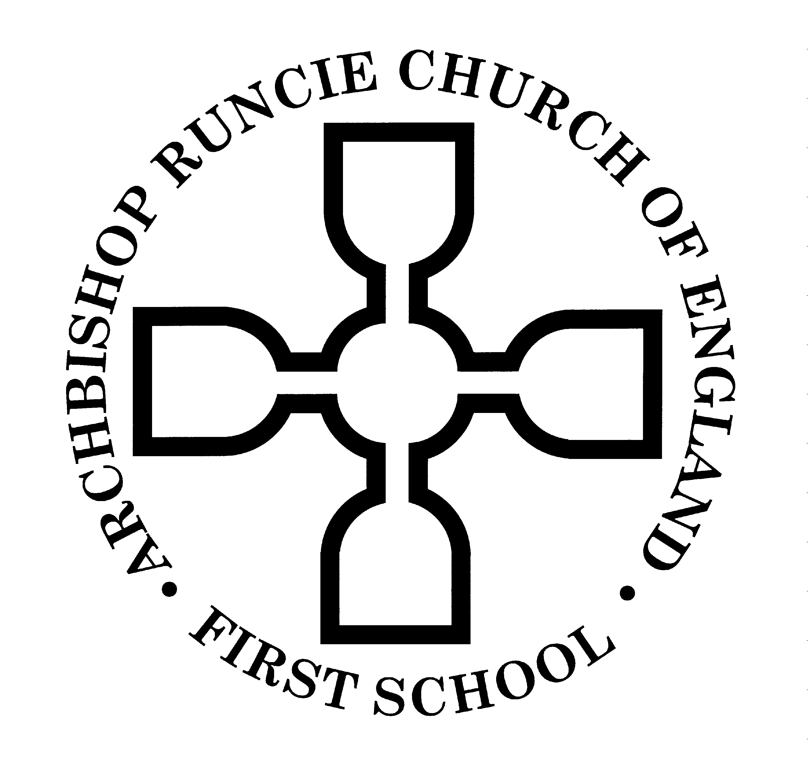
ARCHBISHOP RUNCIE CHURCH of ENGLAND (VA) FIRST SCHOOL

5th November 2018
Year Two Newsletter

Dear Parents,

Welcome back!

We hope everyone has had a lovely half term and is ready for another exciting topic!

This half term we will be embracing the colder weather with our Pole to Pole topic. Today your child has taken part in a full day of drama activities with BigFoot Arts Education. Please talk to them about this experience and all the wonderful things they have been doing. The voluntary contribution for this topic hook is £7.00. Please pay in the usual way via Parent Mail. If you are not yet set up with a ParentMail account, please ask at the school office for a barcode.

Reading books in Y2 will generally be changed on a Wednesday, when children will be given two books to read during the following week. The National Curriculum states that children should read and re-read texts to develop their fluency and pace, these are skills which are hard to establish in a first read through. Therefore we would ask that children read both books at least twice before the following Wednesday. Please remember to write a short note in your child’s Reading Record book each time you listen to your child read and we would love to know how they did with their reading challenge. Please be aware that the children will be starting new Reading Records this half term. Once your child has progressed to chapter books they may just bring one book home at a time so they have time to read it. Please could you ensure book bags are brought to school every day, checked for letters every night and old letters removed please?

Homework will be sent home on a Thursday (please see stickers in your child’s reading record) to be returned to school, marked, on a Tuesday.

PE will usually be taught on a Tuesday. PE kits should be left in school (on cloakroom pegs) and should contain a pair of well-fitting plimsolls/trainers for outdoor lessons. It would be very helpful if any child with long hair could have their hair tied up in a ponytail on these days too. In addition to this, we will do the ‘Golden Mile’ on a Wednesday.

Now the weather is turning much colder, please send your child to school with a hat, gloves etc (named) and a small bag to keep these items in. We would very much appreciate if children are only sent to school in lace up shoes if they can tie their own laces.

KS1 Christmas nativity dates are as follows: Monday 17th December at 5:30 and Tuesday 18th December at 2:00 (ticket information to follow.)

If you have any questions or queries please do not hesitate to catch one of us at the end of the school day.

We have had a very successful first half term and are really looking forward to building upon this together.

Yours sincerely

Mrs Law Mrs Mann
(Mon-Wed) (Wed-Fri)

