[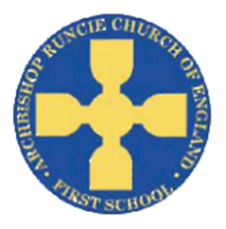](https://www.google.com/url?sa=i&rct=j&q=&esrc=s&source=images&cd=&cad=rja&uact=8&ved=2ahUKEwiSuoC5rb_cAhUF1RoKHfKcAowQjRx6BAgBEAU&url=https://www.newcastlesupportdirectory.org.uk/kb5/newcastle/fsd/service.page?id%3D8Dx9kLf4NJ0&psig=AOvVaw0hbLW86w7T2VgDezq77HoS&ust=1532783445258693)

**History**

The children will be observing and handling evidence to ask questions and find answers to questions about the past. We will be using artefacts and identifying different ways the past has been represented.

**‘Our School’ Autumn Term 2018 Year 2**

**Science**

In Science we will be investigating different materials, their properties and why they are chosen for different purposes. We will be comparing materials used today and 30 years ago and further in the past.

**Physical Education**

In PE this term we will continue to develop our balance, agility & co-ordination skills. We will also improve our long distance running techniques by completing the Golden Mile each week.

**Geography**

In Year 2 we will be using maps to compare where the old school site was in relation to where it is now. We will use Digimaps to support this and help us to plan the best route to get from one site to the other. We will also ask and answer geographical questions

**English**

In English we will be reading the Roald Dahl classic ‘Matilda’. In reading we will be identifying the main events of the story, examining the structure and considering the goals and motives of the characters. The children will then write their own version of the story. We have chosen to study this text across the whole school as it was written in 1988 – the same age as the school.

**Mathematics**

We will be focusing on place value including:

* count in steps of 2, 3, and 5 from 0, and in tens from any number, forward or backward
* recognise the place value of each digit in a two-digit number (tens, ones)
* identify, represent and estimate numbers using different representations, including the number line
* compare and order numbers from 0 up to 100; use <, > and = signs
* read and write numbers to at least 100 in numerals and in words
* use place value and number facts to solve problems

**Art**

We will be working with a local artist to design a sculpture to commemorate our school’s 30th Birthday, using a combination of shapes and techniques.

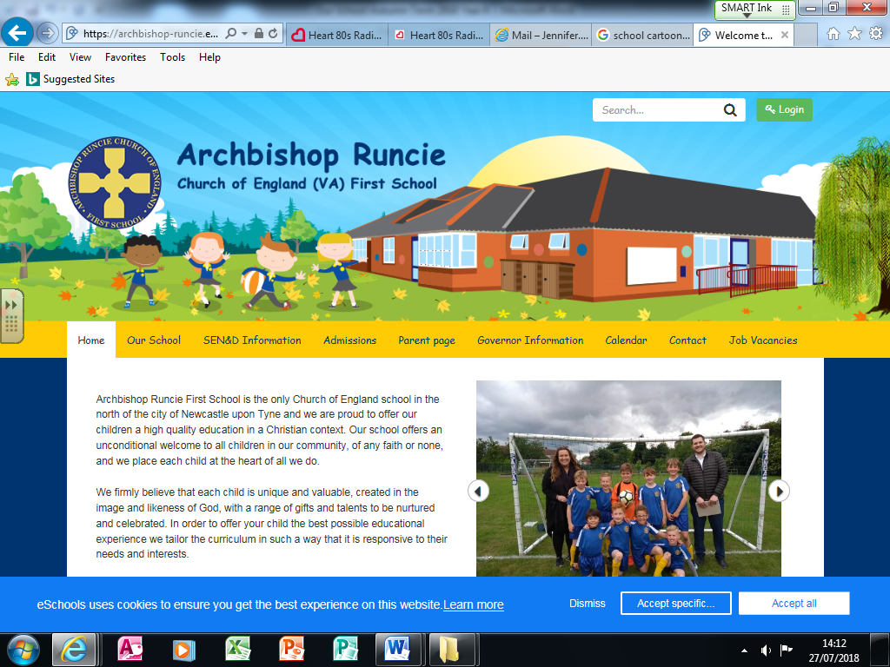

**Religious Education**

We will learn about why we are linked to two different churches – St Nicholas and All Saints.

We will then compare and contrast features of the two churches.

**DT**

We will take part in an enterprising project linked to our topic. As part of this we will plan, design, make and evaluate our product.

**Music**

All children will be learning how to play the recorder, applying their musical knowledge to play melodies, using a range of notes.

**Computing**

The children will be programming on screen, understanding and converting algorithms, predicting what a program will do and spotting and fixing errors.