[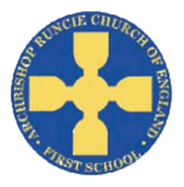](https://www.google.com/url?sa=i&rct=j&q=&esrc=s&source=images&cd=&cad=rja&uact=8&ved=2ahUKEwiSuoC5rb_cAhUF1RoKHfKcAowQjRx6BAgBEAU&url=https://www.newcastlesupportdirectory.org.uk/kb5/newcastle/fsd/service.page?id%3D8Dx9kLf4NJ0&psig=AOvVaw0hbLW86w7T2VgDezq77HoS&ust=1532783445258693)

**History**

The children will use a range of sources to investigate and interpret the past. We will describe different accounts of a historical event, explaining some of the reasons why the accounts may differ.

**‘Our School’ Autumn Term 2018 Year 3**

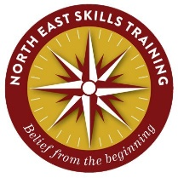

**Science**

Our focus for science this term is plants! We will be learning to identify and describe the functions of different parts of flowering plants and we will also be exploring the requirements for plants and how they vary from plant to plant (such as: light, water, nutrients). Similarly, we will be investigating the way in which water is transported within plans.

**Physical Education**

In PE this term we have the fantastic opportunity to work with Andrew Vince from the North East Skills Training. The children will be taking part in outdoor and adventurous activity challenges both individually and within a team, focusing on orienteering and First Aid training.

**Computing**

The first unit in computing will allow the children to create an algorithm for an animated scene in the form of a story board. The will also write the programme in Scratch to create the animation.

**Mathematics**

We will be focusing on place value including:

* Identify, represent and estimate numbers using different representations.
* Find 10 or 100 more or less than a given number
* Recognise the place value of each digit in a three-digit number (hundreds, tens, ones).
* Compare and order numbers up to 1000
* Read and write numbers up to 1000 in numerals and in words.
* Solve number problems and practical problems involving these ideas.
* Count from 0 in multiples of 4, 8, 50 and 100

**Art**

We will collect information, sketches and resources about our school, adapting and refining ideas as we progress. We will use this information, working alongside a local artist, to create and combine shapes to make a sculpture to represent our school.

**English**

In English we will focus on the Roald Dahl classic ‘Matilda’. Whislt reading this novel we will be invesstigating the use of clauses and subordinate clauses and we will be looking at ways to apply these skills into our writing. We will also be investigating the way paragraphs are used to group informaton and we will begin to apply this skill in our writing. Another one of our focuses is the use of inverted commas to punctuate direct speech. Alongside this we will begin exploring the use of conjunctions, adverbs and prepositions.

**Religious Education**

We will begin our RE topic by writing our own prayers to share in our class prayer book. We will then move on to learning about ‘The Church’. We will be able to describe how the use of the church building reflects belief.

**Music**

The children will continue to learn new tunes on their recorders. They will be listening to and responding to a range of different styles of music. The key performance skills we will develop are to play notes on an instrument with care so that they are clear and to perform with control and awareness of others.

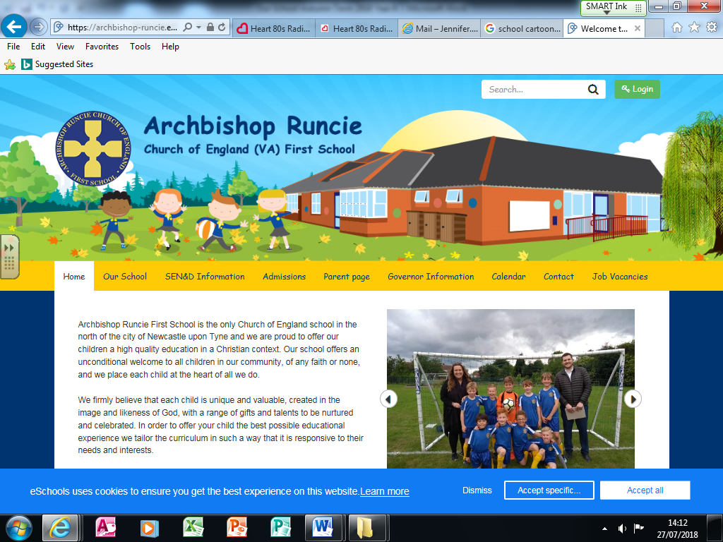

**DT**

We will make products by working efficiently and carefully selecting materials. We will refine our work and techniques as work progresses, continually evaluating the product design.

**Geography**

We will be using fieldwork to investigate the locality of our school. We will then use digital mapping to compare the locations and surroundings of the former school with the position of our current school, investigating how the locality has changed in the past 30 years.