[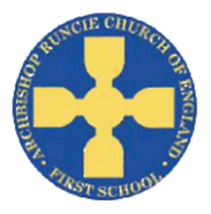](https://www.google.com/url?sa=i&rct=j&q=&esrc=s&source=images&cd=&cad=rja&uact=8&ved=2ahUKEwiSuoC5rb_cAhUF1RoKHfKcAowQjRx6BAgBEAU&url=https://www.newcastlesupportdirectory.org.uk/kb5/newcastle/fsd/service.page?id%3D8Dx9kLf4NJ0&psig=AOvVaw0hbLW86w7T2VgDezq77HoS&ust=1532783445258693)

**History**

The children will use a range of sources to investigate and interpret the past. We will describe different accounts of a historical event, explaining some of the reasons why the accounts may differ.

**‘Our School’ Autumn Term 2018 Year 4**

**Science**

We will be investigating living things and their habitats, using scientific evidence to answer questions and support our findings. We will explore and use classification keys to help group, identify and name a variety of living things in our local and wider environment.

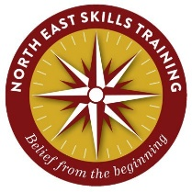

**Physical Education**

In PE this term we have the fantastic opportunity to work with Andrew Vince from the North East Skills Training. The children will be taking part in outdoor and adventurous activity challenges both individually and within a team, focusing on orienteering and First Aid training.

**Mathematics**

We will be focusing on place value including:

* Count in multiples of 6, 7, 9, 25 and 1000.
* Find 1000 more or less than a given number.
* Recognise the place value of each digit in a four digit number (thousands, hundreds, tens and ones).
* Order and compare numbers beyond 1000.
* Identify, represent and estimate numbers using different representations.
* Round any number to the nearest 10, 100 or 1000.
* Solve number and practical problems that involve all of the above and with increasingly large numbers.

**Computing**

In Year 4 we are learning how to keep safe when using the internet. We will then become software developers! We will use Scratch to design and make an educational game. We will evaluate our game and explain how the algorithm of our games work.

**Art**

We will collect information, sketches and resources about our school, adapting and refining ideas as we progress. We will use this information, working alongside a local artist, to create and combine shapes to make a sculpture to represent our school.

**English**

In English we will focus on the Roald Dahl classic ‘Matilda’. In reading we will be able to identify themes and chronology of our key story, noting how Roald Dahl conveys the passing of time and how dilemmas are set up and solved. In writing we will use expanded noun phrases with modifying adjectives to describe characters from the story, as well as organising paragraphs around a theme. We will use this information to then plan and write our own versions of Matilda!

**Music**

The children will continue to learn new tunes on their recorders. They will be listening to and responding to a range of different styles of music. The key performance skills we will develop are to play notes on an instrument with care so that they are clear and to perform with control and awareness of others.

**Religious Education**

We will begin our RE topic by writing our own prayers to share in our class prayer book. We will then move on to learning about ‘The Church’. We will be able to describe how the use of the church building reflects belief.

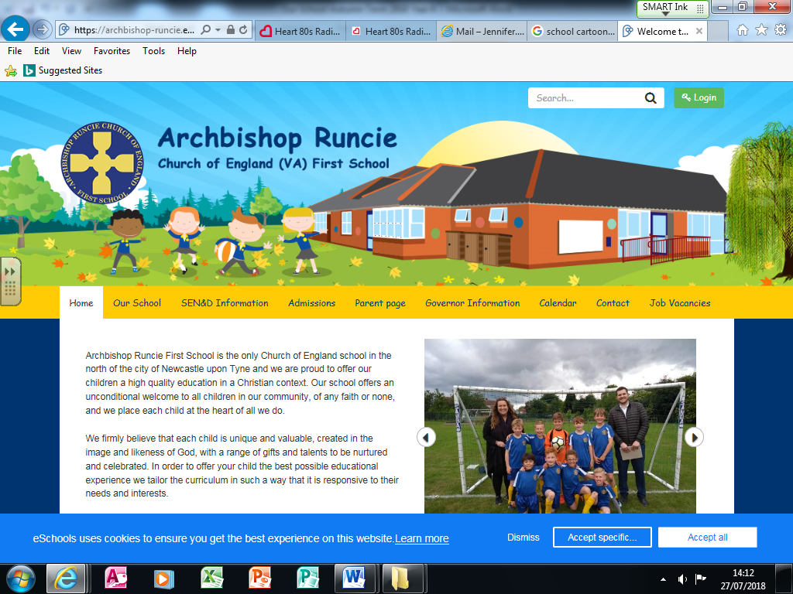

**DT**

We will make products by working efficiently and carefully selecting materials. We will refine our work and techniques as work progresses, continually evaluating the product design.

**Geography**

We will be using fieldwork to investigate the locality of our school. We will then use digital mapping to compare the locations and surroundings of the former school with the position of our current school, investigating how the locality has changed in the past 30 years.