Year 3

Summer Term 2

**English:** We will write a persuasive letter, to encourage people to eat in a Stone Age Theme restaurant as well as developing our own delicious Stone Age themed menus. Following from our narrative, we will produce our own Stone Age inspired play scripts in order to create our own stop motion videos.

**Maths**: We will be learning all about angles including:

* Right-angles, obtuse and acute angles and recognising them in a range of contexts.

We will all be learning about measures including:

* Measuring length and capacity in a number of practical contexts as well as problem solving.

**PE:** In PE this term we will develop our running, jumping and throwing skills in preparation for sport’s day.

**Computing:** We are going to develop our programming skills using a stop-animation app to create our own stone-age animations.

C:\Program Files\Microsoft Office\MEDIA\CAGCAT10\j0285750.wmf

**Science**: We will be working scientifically in order to investigate rocks and fossils and their properties. We will also be learning about the formation of rocks and fossils and representing this in different ways.

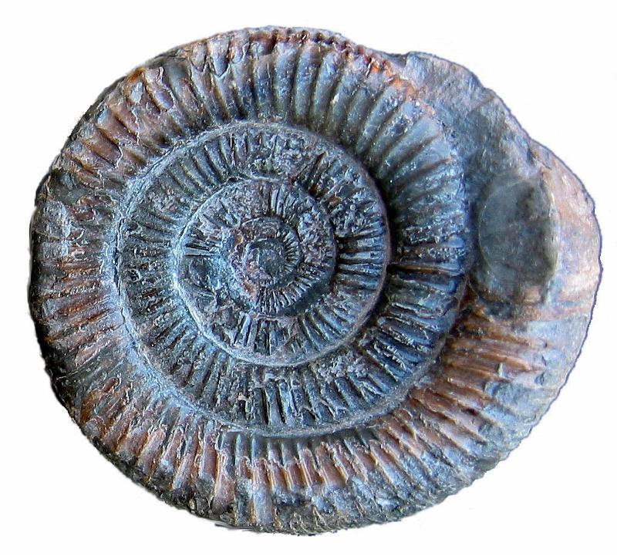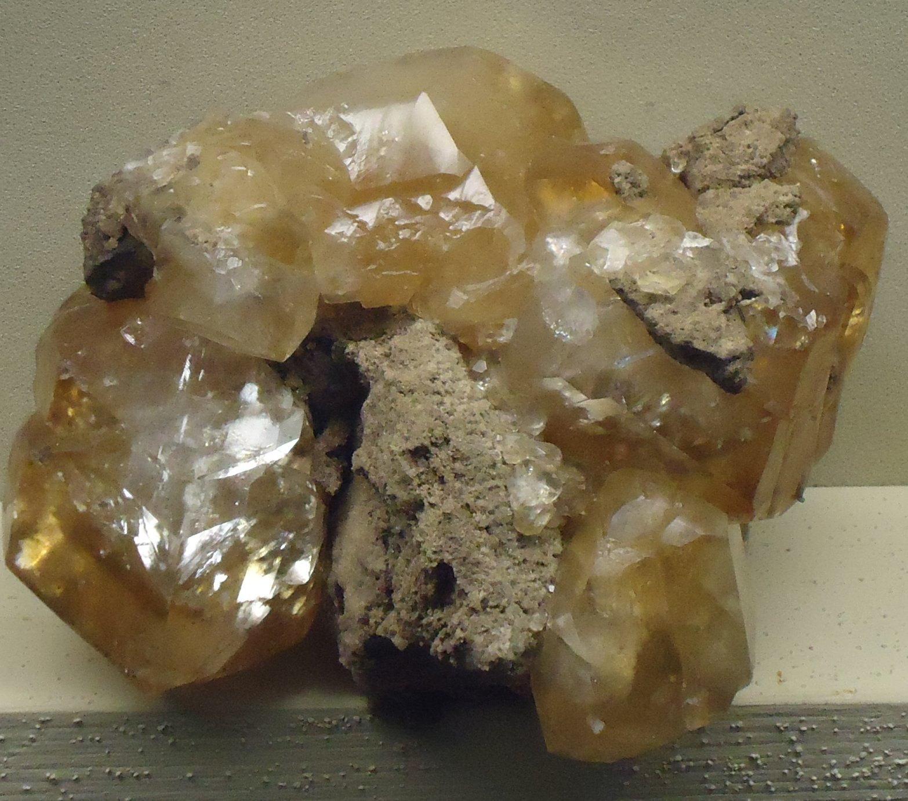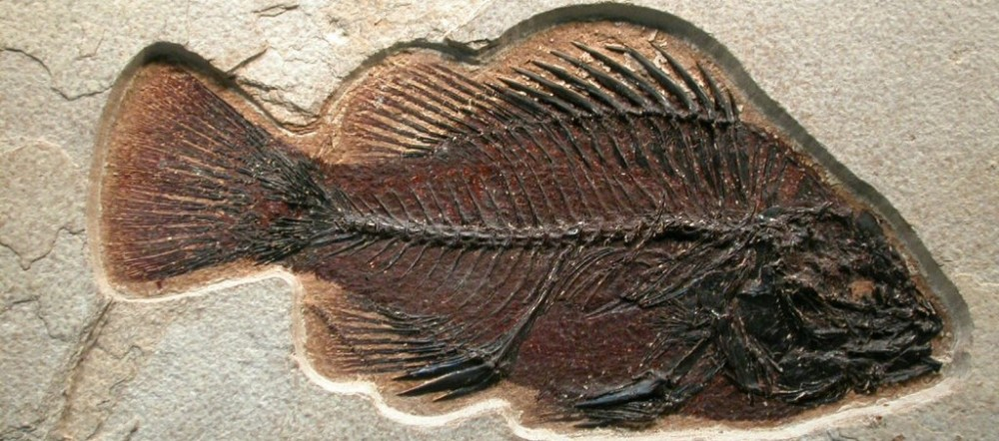

**Art:** We will be creating our own Stone Age inspired art work developing our sketching, drawing and shading skills as well as experimenting with different mediums. We will also evaluate our own and others’ work.

**[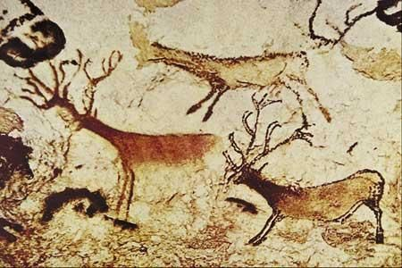](http://www.studyblue.com/notes/note/n/art-of-the-stone-age-30000-2000/deck/6126927)**

**Personal, Social, Health Education and Citizenship:**

We will learn about personal well-being and create a class Emotional Bank Account as well as recognising a range of emotions and how to manage these different feelings.

**RE:** We will continue to learn about how Jesus changed lives by making connections between the Bible stories and Christian belief. We will then also explore how Christian faith is expressed through art.

**History:** We will investigate and interpret the past by exploring the Stone Age and in particular how life changed during this time.

**Music:** We will listen to, appreciate and understand a wide range of music drawn from great composers and musicians. We will perform by maintaining a simple part within a group, performing with control and awareness of others.

C:\Program Files\Microsoft Office\Media\CntCD1\Animated\j0213486.gif

How did life change during the Stone –Age?