[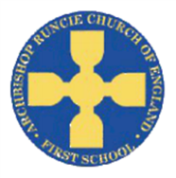](https://www.google.com/url?sa=i&rct=j&q=&esrc=s&source=images&cd=&cad=rja&uact=8&ved=2ahUKEwiSuoC5rb_cAhUF1RoKHfKcAowQjRx6BAgBEAU&url=https://www.newcastlesupportdirectory.org.uk/kb5/newcastle/fsd/service.page?id%3D8Dx9kLf4NJ0&psig=AOvVaw0hbLW86w7T2VgDezq77HoS&ust=1532783445258693) **‘Go Green’ Autumn 1 Term 2019 Year 4**

**Mathematics**

We will be focusing on place value before moving onto addition and subtraction. This includes:

* Count in multiples of 6, 7, 9, 25 and 1000.
* Find 1000 more or less than a given number.
* Recognise the place value of each digit in a four digit number (thousands, hundreds, tens and ones).
* Order and compare numbers beyond 1000.
* Round any number to the nearest 10, 100 or 1000.
* Solve number and practical problems that involve all of the above and with increasingly large numbers.
* Add and subtract numbers with up to 4 digits using the formal written methods of columnar addition and subtraction

**Science**

We will be investigating living things and their habitats, using scientific evidence to answer questions and support our findings. We will explore and use classification keys to help group, identify and name a variety of living things in our local and wider environment. We will link this to what we learn about in Geography in terms of a changing planet.

**Computing**

In Year 4, we are learning how to keep safe when using the internet. We will then become software developers! We will use Scratch to design and make an educational game. We will evaluate our game and explain how the algorithm of our games work.

**Physical Education**

In PE, children will take part in outdoor and adventurous activity challenges both individually and within a team, working on both physical and cooperative skills.

**Religious Education**

We will begin our RE topic by writing our own prayers to share in our class prayer book. We will then move onto our topic, ‘People of God’, which focuses on stories from the Old Testament.

**Geography**

We are going to be using our locational knowledge to first examine different climate zones before we look at the link between human and physical geography, finding out how human activity affects climate, animals (closely linking to Science) and other humans. We will then build on their previous knowledge of the Amazon rainforest, looking at the current, topical fires and the effect this is having to the climate and the rest of the world.

**English**

We will be examining fairy tales, using our knowledge of ones we have heard before but particularly focusing on Little Red Riding Hood, reading both classic (Brothers Grimm) and modern (Roald Dahl) versions, digging deeper into the themes and conventions. This will link in with our writing, where we will rewrite part of the story in the traditional style and then a comedic, Dahl-inspired piece. We will then move onto playscripts, looking at how they work, examining famous examples, then writing our own, linked to the topic of ‘Go Green’. We will then synthesise our work collectively into a piece that the children will perform for you!

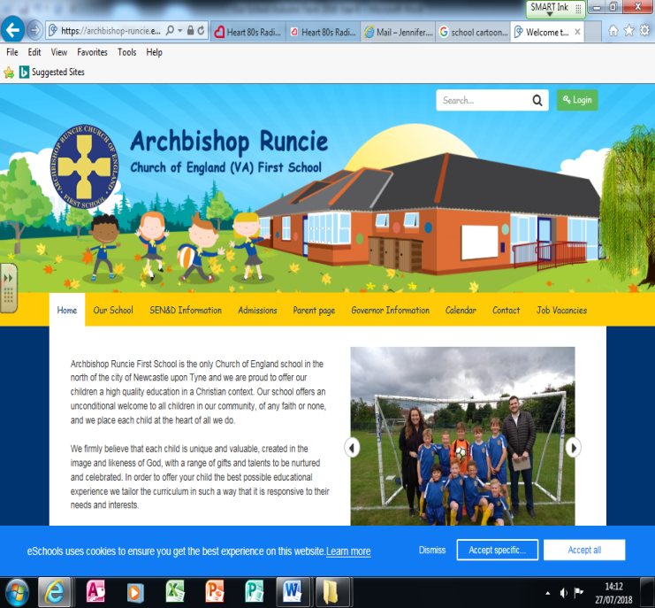

**Personal, Social and Emotional Development (PSED)**

Our first topic will be, ‘It’s Good to be Me’, all about figuring out ourselves as people and how we cope with our own emotions and thoughts.

**Music**

The children will learn new tunes on their recorders, including from *Mamma Mia*!. They will be listening to and responding to a range of different styles of music. The key performance skills we will develop are to play notes on an instrument with care so that they are clear and to perform with control and awareness of others.

**Spanish**

The children will continue to work on the Spanish they learnt in Year 3, working on greetings and numbers up to 20.

**DT**

We will begin with some work based around food, understanding seasonality, and know where and how a variety of ingredients are grown, reared, caught and processed. We will then link our DT with our Computing, looking at evaluating our designs using algorithms.