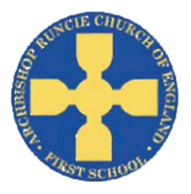
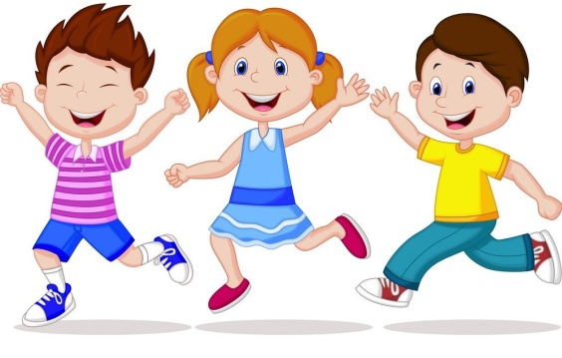
Spring Term 2019 Nursery –
Traditional Fairy Tales / ECO Warriors/ Chinese New Year
Characteristics of effective learning
I will be: Finding out and exploring. Willing to have a go. Playing with what I know. Being involved and concentrating. Enjoying achieving. Persistent and keep on trying. Sharing my own ideas. Making links. Choosing ways to do things.

Mathematics
I will be:
- Counting, recognising and ordering numbers.
- Matching numerals to quantities.
- Naming and describing 2D shapes.
- Creating repeated patterns.
- Making 3D models.
- Exploring characteristics of everyday objects.
- Learning to form numbers.

Communication and Language
I will be:
- Learning to follow instructions.
- Taking part in circle time activities.
- Recreating roles of real life family situations and fictional stories.
- Exploring the meaning and sounds of new words.
- Learning how to describe myself.
- Talking about my family and friends.
- Thinking about the sequence of events in stories.

Literacy
I will be:
- Linking sounds to letters.
- Hearing and saying sounds in words.
- Beginning to blend CVC words.
- Learning to write my name.
- Give meaning to the marks I make.
- Writing identifiable letters.
- Listening to lots of different stories.

Personal, Social and Emotional Development
I will be:
- Learning to create class rules with my friends.
- Participating in turn taking games.
- Trying and selecting new activities independently.
- Gaining confidence to talk within a large group.
- Learning about friendship and how to value and respect others.
- Welcoming our new friends.

*Discussing my likes and dislikes.

Learn to love, love to learn.
Expressive Arts and Designs
I will be:
- Exploring different sounds instruments make.
- Using a range of media to make marks.
- Naming and mixing colours.
- Designing and building a model.
- Role playing different scenarios with my friends.
Knowledge and understanding of the world
I will be:
- Talking about similarities and differences between me and my friends.
- Talking about events that I can remember.
- Talking about where I live and who I live with.
- Cultures and festivals.

Physical development
I will be:
- Negotiating space.
- Using control and co-ordination.
- Developing our fine motor skills by using playdough and funky finger activities.
- Trying to hold a pencil correctly.

Religious Education
- This term in RE we will be learning about people who are important to us.

