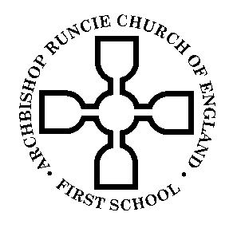
Archbishop Runcie Church of England (VA) First School

SCHOOL TERMS AND HOLIDAYS 2017-2018

School Terms | No. of Days | Holidays | No. of Days
Tuesday 5th** September to  Friday 20th October 2017 | 34
 |  | Monday 23rd October to  Monday 30th October 2017 | 6
Tuesday 31^{st**} October to  Friday 22nd December 2017 | 39
 |  | Monday 25th December 2017  to Friday 5th January 2018 | 10
Monday 8th January 2018 to  Friday 9th February 2018 | 25
 |  | Monday 12th February to  Friday 16th February 2018 | 5
Monday 19th February to  Thursday 29th March 2018 | 29
 |  | Friday 30th March to  Friday 13th April 2018 | 11
Monday 16th April to  Friday 4th May 2018 | 15
 |  | Monday 7th May (Bank Holiday) | 1
Tuesday 8th May to  Thursday 24th** May 2018 | 13
 |  | Friday 25^{th**} May to  Friday 1st June 2018 | 6
Monday 4th June to  Friday 20th July 2018 | 35
 |  | Monday 23rd July to  Friday 31st August 2018 | 30

School will be closed on the following days for staff training:

**Training Days**

Monday 4th September 2017
Monday 30th October 2017
Friday 25th May 2018

