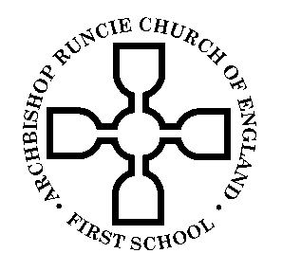
Archbishop Runcie Church of England (VA) First School

SCHOOL TERMS AND HOLIDAYS 2016-2017

School Terms | No. of Days | Holidays | No. of Days
Tuesday 6^{th*} September to  Thursday 20^{th*} October 2016 | 33
 |  | Monday 24th October to  Friday 28th October 2016 | 5
Monday 31st October to  Wednesday 21st December 2016 | 38
 |  | Thursday 22nd December 2016 to  Wednesday 4th January 2017 | 10
Thursday 5th January 2017 to  Friday 17th February 2017 | 32
 |  | Monday 20th February to  Friday 24th February 2017 | 5
Tuesday 28^{th*} February to  Friday 7th April 2017 | 29
 |  | Monday 10th April to  Friday 21st April 2017 | 10
Monday 24th April to  Friday 28th April 2017 | 5
 |  | Monday 1st May (Bank Holiday) | 1
Tuesday 2nd May to  Thursday 25th* May 2017 | 18
 |  | Monday 29th May to  Friday 2nd June 2017 | 5
Monday 5th June to  Friday 21st July 2017 | 35
 |  | Monday 24th July to  Friday 1st September 2017 | 30

School will be closed on the following days for staff training:

**Training Days**

Monday 5th September 2016
Friday 21st October 2016
Monday 27th February 2017
Friday 26th May 2017

