Physical Education and Sport Premium
The Government is providing additional funding of £150 million per year from 2013 to 2020 to improve the provision of PE and Sport in primary schools. It must be used to fund additional and sustainable improvements to the provision of PE and sport and to encourage the development of healthy, active lifestyles.
At Archbishop Runcie we believe Physical Education and Sport play an important role in the development of every child, with the potential to change young people’s lives for the better. We have welcomed the Government’s investment in providing additional funding until 2020 to improve provision of Physical Education and Sport in primary schools.
We are committed to using this resource:
- To employ a specialist PE teacher to raise standards in PE and sport;
- To develop teachers’ competence and confidence to deliver high quality PE lessons (two hours per week in curriculum time);
- To seek to provide additional wide-ranging PE activities outside of curriculum time;
- To encourage children to lead healthy, active lifestyles;
- To provide opportunities for children to develop their leadership skills;
- To offer greater opportunities for sporting competition;
- To signpost pupils to sporting opportunities in the community;
- To continue to develop our PE resources;
- To improve playground equipment and quality of play.

In both 2015/16 and 2016/17 school received £8358.

Outcomes for 2015/16
√ All pupils were involved in regular physical activity encouraging healthy and active
lifestyles
√ Sporting activities and achievements celebrated throughout the school year
√ PE Week – taster sessions of a variety of sporting activities culminating in Sports
Day attended by parents
√ Increased participation in competitive sport through Gosforth Schools Trust
√ Increased staff confidence in delivering and assessing high quality PE
√ Improvements in standards achieved by all children.

In 2016/17 this funding is being used to:
- Fund a specialist PE teacher to work alongside class teachers raising
standards for the children and providing valuable CPD for staff (£5250);
- Support the involvement of the least active children in physical activity through
before and after school clubs;
- Purchase of SLA with Local Authority for development of school sport (£975);
- Fund training for PE lead in Outdoor Activities (£240);
- Fund involvement in local tournaments and festivals eg Quicksticks, tennis,
orienteering & football;
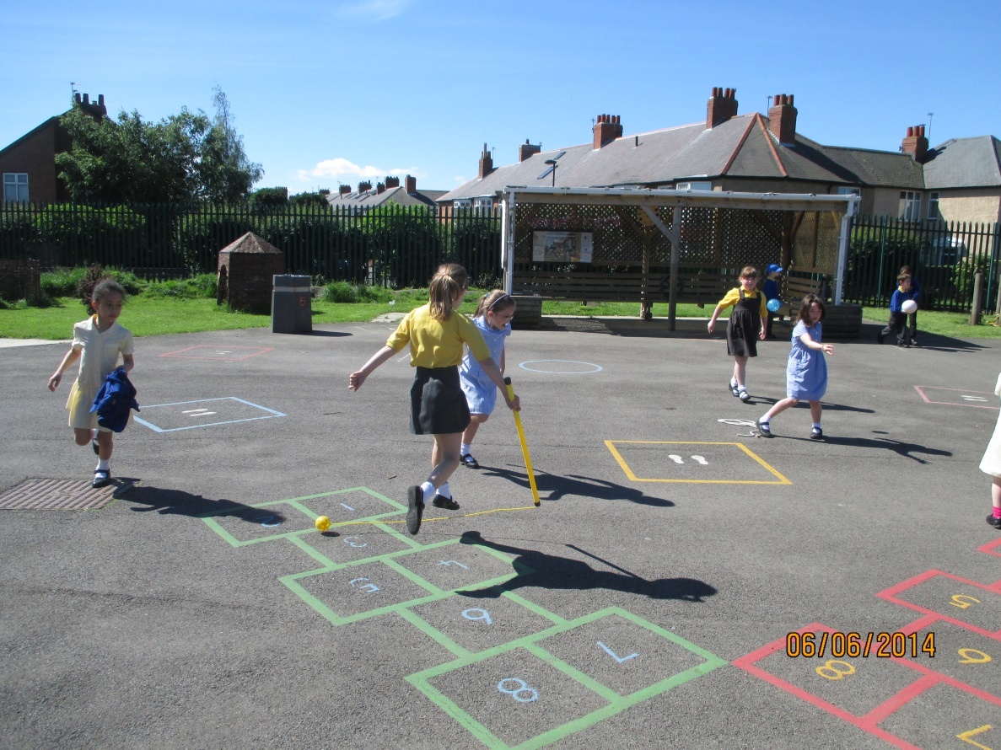
- Fund activities for PE Week, culminating in Sports Day.
